ASSESSING THE IMPACT OF HOSPITALITY MANAGEMENT PRACTICES ON THE SERVICE QUALITY OF RESORT IN PANDI, BULACAN.
In Partial Fulfilment in the Subject HMC 8- Research in Hospitality

Submitted to:

Mr. Jurael Sayo Inson, LPT, PhD

Research Professor

Submitted by:

Rico, Rhacel P.

Eli, Norelyn O.
Dela Cruz, Ashelle N.

Fronda, Mark Angelo

Libiran, Jade Alzel

Ostos, Cj M.

BSHM- 3A

18 October 2025

ACKNOWLEDGEMENT

First, we would like to offer our sincerest appreciation to God Almighty for His divine guidance and wisdom, which have been our guiding light throughout the duration of this research study.
Second, we would also appreciate the help of our research professor, Dr. Marlita V. Madera, LPT, PD-TQM, FRIEdr, FRIM, for her total assistance, patience, and expertise. Her professional judgment was most crucial in our findings of finishing our research successfully.

Third, we would also like to extend our most sincere gratitude to Dr. Jurael S. Inson, Mrs. Ma. Victoria T. Morales, and Ms. Precious Montillano for their great help in validating the survey questions and interview questions used in our research. Their professionalism greatly helped to establish the reliability and validity of our research instrument.

Fourth, we thank most of our loving families for their constant support, both emotional and financial, during the duration of this research. We also want to thank those people who ever inspired and boosted us, primarily our team whose additional effort, motivation, and moral support played a major role in assisting us in moving further ahead and accomplishing these activities.

Furthermore, we also would like to express our deepest appreciation towards all the informants for giving us appropriate information, which was of a very great assistance to the success of this study. We also extend our heartfelt thanks to the College of Mary Immaculate Inc. for full support and for allowing us to undertake this research in their institutions.

ABSTRACT

This study explored the barriers affecting enrollment in the Bachelor of Science in Tourism Management (BSTM) program at the College of Mary Immaculate. It aimed to outline the demographic characteristics of participants based on age and gender, identify the internal and external elements affecting enrollment choices, uncover common misconceptions and concerns about Tourism Management, and suggest approaches to enhance program enrollment. The researchers utilized a mixed-methods strategy incorporating descriptive statistics and thematic analysis. One hundred fifty respondents, including grade 12, first-year, and second-year students, took part in the survey, and qualitative responses were examined thematically. Findings indicated that financial challenges were the most significant obstacle, with students showing that the primary barrier was money, with students highlighting the difficulty of tuition and other expenses like uniforms, activities, and training. Lack of promotion has the least impact on enrollment, while social pressure and academic perception had a moderate impact. Thematic findings also revealed misunderstandings, such as the idea that tourism just leads to jobs as a flight attendant or that specific physical attributes are necessary, as well as worries about job security and income. The respondents also suggested solutions like more scholarships, industry exposure, and marketing campaigns. The study concludes that addressing financial barriers, clarifying misconceptions, and increasing program awareness are all essential to encouraging higher enrollment in the BSTM program.

TABLE OF CONTENTS

 | Page
TITLE PAGE | i
ACKNOWLEDGEMENT | ii
ABSTRACT | iii
TABLE OF CONTENTS | iv
LIST OF TABLES | vii
LIST OF FIGURES | viii
LIST OF APPENDICES | vi
CHAPTER I: THE PROBLEM AND IT’S BACKGROUND
Introduction | 1
Theoretical Framework | 4
Conceptual Paradigm | 5
Statement of the Problem | 8
Scope and Delimitations | 9
Significance of the Study | 10
Definition of Terms | 11
Review of Related Literature and Studies | 13
Synthesis | 36
CHAPTER II: RESEARCH METHODS
Research Design | 39

Research Locale | 40
Research Informants | 41
Research Instruments | 42
Data Gathering Procedure | 46
Data Analysis | 46
Ethical Considerations | 47
CHAPTER III: FINDINGS AND DISCUSSIONS
Demographic Profile of the Respondents | 48
Internal Factors Pursuing the Bachelor of Science in Tourism  Management degree | 50
External Factors Pursuing the Bachelor of Science in Tourism  Management degree | 54
Common Misconception or Concerns about Pursuing a degree  in Tourism Management | 59
Strategies to Improve student’s Enrollment in the program | 64
CHAPTER IV: SUMMARY, CONCLUSIONS, AND RECOMMENDATIONS
Summary | 69
Findings | 71
Conclusions | 74
Recommendations | 75
REFERENCES | 76
APPENDICES | 85

Letter Request for Validation & Validation Tool | 86
Letter of Request to Conduct the Study | 95
Validated Survey and Interview Questionnaire | 96
Documentation of Collecting Data | 101
Curriculum Vitae of Dianne Altea Ballesteros | 103
Curriculum Vitae of Juan Gabriel Chavez | 104
Curriculum Vitae of AJ Cruz | 105
Curriculum Vitae of Mariella Magtalas | 106

LIST OF TABLES

No. | Table Title | Page
1 | Demographic Profile of the Respondents in Terms of Year level | 48
2 | Demographic Profile of the Respondents in Terms  of Gender | 49
3 | Responses on Financial Constraints (1 to 5) | 50
4 | Responses on Social Pressure (6 to 10) | 52
5 | Responses on Academic Perception (11 to 15) | 54
6 | Responses on Lack of Promotion (16 to 20) | 56
7 | Summary of Factor Means and Ranking | 58
8 | Influence of academic perception as the factor affecting students to enroll in BSTM | 59
9 | Career Uncertainty as the factor affecting students  to enroll in BSTM | 62
10 | Social and family influence as the factor affecting students  to enroll in BSTM | 63
11 | Role of promotion and Marketing as the factor affecting  students to enroll in BSTM | 64
12 | Lack of moral support as the factor affecting students  to enroll in BSTM | 66
13 | Academic Demands and Curriculum Difficulties as the  factor affecting students to enroll in BSTM | 67

LIST OF FIGURES

No. | Figure Title | Page
1 | Assessing The Impact of Hospitality Management Practices on The Service Quality of Resort in Pandi, Bulacan. | 5

CHAPTER I: THE PROBLEM AND ITS BACKGROUND

Introduction
The hospitality industry plays a significant role in promoting tourism and contributing to local economic growth. Resorts, in particular, serve as vital attractions that offer recreation, relaxation, and unique experiences for guests. The success of these establishments greatly depends on the quality of service they provide and the satisfaction of their customers. To achieve this, hospitality management practices such as excellent customer service, staff training, and proper facility maintenance must be effectively implemented. In Pandi, Bulacan, the growth of tourism has led to an increase in local resorts that address the needs of both guest and local people. However, some of these establishments face challenges related to the competency of their employees. In many cases, resort workers are hired through recommendations or personal connections rather than their knowledge and skills in the hospitality field.
These practices often result in inconsistent service quality and lower customer satisfaction. Assessing proper hospitality management practices can help address this issue by promoting employee training, service standards, and professional development. According to recent research, service quality has a major impact on customer happiness in the hospitality industry.
According to Nneoma and Uwabor (2021), improvements in service quality, such as tangibility, reliability, and responsiveness, increased customer satisfaction and loyalty in resort hotels in Southeast Nigeria. Similarly, Shoon Lei Myint Mo (2024) emphasized the significance of personnel training, facility upgrades, and environmental management by

noting that human elements, environmental considerations, and technical quality all had a positive impact on tourist satisfaction at Ngwe Saung Beach in Myanmar. However, despite the valuable insights provided by these studies, there is little information on how hospitality management methods affect customer satisfaction and service quality in resorts in Pandi, Bulacan, Philippines.
This study, inspired by the insight and guidance of the department head of Hospitality Management, particularly through the subject Service Quality Management at the College of Mary Immaculate, aims to deepen the researchers knowledge and understanding of how assessing hospitality management practices can improve customer satisfaction in resort service quality in Pandi, Bulacan. The findings of this research will serve as a valuable reference for resort owners, employees, and future researchers in enhancing the standards and practices of the local hospitality industry.

Theoretical Framework

The purpose of the theoretical framework for this research is to investigate the connection between Hospitality Management Practices and service quality, as well as customer satisfaction, in Pandi, Bulacan resorts. Additionally, it helps in choosing research tools and interpreting the study's results.

First, the Exchange Process Theory by George Homans (1961) explains that individuals make decisions in social interactions based on a careful evaluation of rewards and costs. People choose actions that provide the greatest benefits while avoiding those that bring disadvantages. In the hospitality setting, guests assess their resort experience by comparing reward, such as good service, clean facilities, safety, and comfort with costs, including poor service, long waiting times, or unmet expectations. When the rewards outweigh the costs, guests feel satisfied, valued, and are more likely to return. Similarly, employees experience exchanges within the workplace. They gain rewards such as proper training, managerial support, recognition, and a fair workload, while their costs include workplace stress, unclear instructions, or lack of resources. When employees receive adequate rewards, they become more motivated, engaged, and capable of delivering high-quality service to guests. This theory is relevant to the study because it illustrates how effective Hospitality Management Practices increase rewards and reduce costs for both employees and guests, ultimately leading to better service quality and higher customer satisfaction in resorts in Pandi, Bulacan.

Second, the Job Demands-Resources Model (JD-R) by Demerouti (2001) explains that employee performance and motivation depend on the balance between job demands and job resources. Job demands refer to physical, emotional, or workload pressures, while job resources include training, support, tools, and a positive work environment. When employees receive sufficient resources, they experience lower stress and higher engagement, allowing them to perform their tasks more effectively. Conversely, a lack of resources can lead to burnout and poor service delivery. This theory is relevant to the study because it shows how proper Hospitality Management Practice such as staff training, clear procedures, and managerial support act as essential job resources that enhance employee performance. Well-equipped and supported employees are better able to provide high-quality service, which directly contributes to higher customer satisfaction in resorts in Pandi, Bulacan

Third, the SERVQUAL Model by Parasuraman, Zeithaml and Berry (1985) is used to measure service quality through five dimensions: reliability, responsiveness, tangibility, assurance, and empathy. Reliability refers to the ability to consistently deliver promised services accurately, while responsiveness measures the willingness and promptness of staff in assisting customers. Tangibility examines the physical facilities, equipment, and appearance of personnel, whereas assurance reflects the knowledge, competence, and courtesy of staff that instill trust in guests. Empathy focuses on providing caring, individualized attention to guests. The relevance of this model lies in its ability to provide an empirical and structured framework for assessing the impact of Hospitality Management Practices on service quality. By applying SERVQUAL, resorts in Pandi, Bulacan can systematically evaluate strengths and areas for improvement in their service delivery, ultimately enhancing customer satisfaction and operational excellence.

In conclusion, this framework demonstrates that the use of effective Hospitality Management Practices can boost employee productivity and involvement, which in turn improves service quality and, ultimately, increases customer satisfaction.Conceptual Diagram

Conceptual Framework
This study aims to explores the hospitality management practices of selected resorts in Pandi, Bulacan, with the objective of determining areas for improvement and enhancing customer satisfaction. Data were collected through surveys administered to resort staff and managers, focusing on demographic factors such as age, gender, job position, and educational background. The gathered information was systematically organized, evaluated, and subjected to statistical analysis—including the computation of mean, median, mode, and standard deviation—to generate meaningful recommendations for strengthening hospitality management practices and increasing overall customer satisfaction.

OUTPUT
PROCESS
INPUT
1. Data Organization & Scoring
•Encode survey responses.
•Categorize responses based on the variables.
‎2. Statistical Treatment
•Mean
•Median
•Mode
‎•Standard Deviation (SD)
‎
•Recommendations for Improving hospitality management practices.
‎
•Proposed improvement to improve customer satisfaction.
‎1. Survey administered to resort staff and managers in selected resorts in Pandi, Bulacan.
‎2. Demographic Profile of Respondents, such as:
-Age
-Sex
-Position/Job role
-Educational background

Statement of the Problem

This study seeks to determine the impact of hospitality Management Practices on the Service Quality of Resorts in Pandi, Bulacan.
This study aims to answer the following questions.
1. What are the perception level of the on hospitality management practices in terms of:
1.1 service protocols
1.2 training and development
1.3 recognition and reward
2. How the perception level on hospitality management practices impacted the service quality in the resorts in terms of:
2.1 Responsiveness
2.2 Customer Satisfaction
2.3 Competence
2.4 Consistency
2.5 Problem Resolution
3. Is there a significant impact of hospitality management practices to service quality in resorts in Pandi?
4. What strategies can resort in Pandi, Bulacan implement to strengthen hospitality management practices and improve service quality?

Research Hypothesis

• Null Hypothesis
– There is no Significance relationship in terms of Hospitality Management Practices, Service quality, and Customer Satisfaction in resort.

• Alternative Hypothesis
– There is a significant relationship in terms of Hospitality Management Practices, Service quality, and Customer Satisfaction in resort.

Scope and Delimitation of the study

This study focuses on different factors that influence service quality and overall customer satisfaction on public resorts in Pandi, Bulacan. This study will focus on different public resorts such as Amana Water park, Sitio Antonio, Villa Concepcion
This study examining the key aspects of the hospitality management including the staff training and management strategies that directly the guest/customer experience. The target respondents that only in Pandi customers/guests only.
Further, this study is limited to public resorts located in the municipality of Pandi, Bulacan. The findings may not represent the conditions of private resorts or hospitality establishments outside the area. In additions the study relies on the responses of customers and guests who are available and willing to participate during the data gathering period which may introduce response bias Factors such as seasonal tourism trends, individual customer expectations and external influences on service quality were not extensively measured and may affect the venerability of the results.

Significance of the Study

This study is significant because it examines how hospitality management practices impact the service quality of resorts in Pandi, Bulacan. The findings will benefit the following:

Students

For Resorts Guest

The results of this study will help determine the overall customer satisfaction through providing assessment on improving customer experience. This will also result on promotion of quality standards in the hospitality management. The study’s insight will allow results in ensuring that services will meet evolving needs of the customers.

For Managers and Employees

The results of this study will benefit managers and employees by providing insights into which hospitality management practices effectively enhance service quality. This knowledge can help them improve daily operations, streamline workflows, strengthen staff performance, and ultimately exceed customer expectations. By applying these findings, managers and employees can ensure a more consistent, efficient, and high-quality service experience for all guests.

Business Owner

The results of this study will benefit the resort owner by providing guidance on how to strengthen staff through proper training and effective management practices. This can lead to improved service quality, a better overall guest experience, higher customer retention, and increased profitability. By implementing the researchers recommendations, business owners can enhance operational efficiency, maximize revenues, cost efficient, and ensure the long-term success and reputation of their business.

Future Researchers

The researchers conducted this study to provide data that can serve as a reference to the future researchers who are interested on hospitality management, service quality and operational improvement in the Hospitality Industry

Definition of Terms

Hospitality Management Practices – refers to the structured knowledge, training, procedures, and standards used in managing hospitality operations. These practices ensure that staff deliver proper service protocols, maintain efficiency, and provide a high-quality guest experience.

Service Quality – refers to the level of excellence of the service delivered by a business. It reflects how well the service meets or exceeds customer expectations in terms of performance, consistency, and overall experience.

Customer Satisfaction – refers to the degree to which customers feel pleased or fulfilled based on the service they receive from a business. It indicates whether the service provided meets their needs, expectations, and standards.

Tangibility – refers to the physical elements of a business that can be seen, touched, or measured—such as facilities, equipment, amenities, and appearance of personnel. It is one of the key dimensions of service quality.

Reliability – refers to the ability of a business to consistently deliver dependable and accurate service. It includes fulfilling promises, performing services correctly, and maintaining trust with customers.

Responsiveness – refers to the willingness and promptness of staff in assisting customers. It includes providing quick service, addressing concerns immediately, and being attentive to guest needs.

Service Protocol – refers to a set of standardized procedures and guidelines that staff follow to ensure consistent, efficient, and high-quality service for guests. This includes steps for greeting guests, handling complaints, and maintaining safety and hygiene standards.

Training and Development – refers to the systematic process of enhancing employees’ knowledge, skills, and competencies to perform their job effectively. In the hospitality context, it includes orientation, on-the-job training, workshops, and continuous professional development to improve service delivery.

Recognition and Reward – refers to the acknowledgment and appreciation of employees’ efforts and achievements, often accompanied by incentives or benefits. It includes verbal praise, certificates, bonuses, or other forms of reward that motivate employees to maintain high performance and engagement.

Review of Related Literature and Studies

The objective of this literature is to study, analyze, and synthesize existing local and international research that examines the relationship between hospitality management practices and service quality within the hospitality industry. As the hospitality industry continues to expand, businesses strive to meet the growing expectations of customers. To achieve consistent service quality, establishments rely on effective hospitality management practices. Moreover, service quality remains a central factor influencing customer satisfaction, loyalty, and the overall reputation of a hospitality business. Understanding the relationship between hospitality management practices and service quality is essential, as strong management practices often lead to improved service performance and better customer experiences. This review of related literature also supports the conduct of the present study in Pandi, Bulacan at the College of Mary Immaculate, providing a theoretical foundation for understanding the factors influencing service quality within local hospitality sectors.

Service Recovery Practices in Hospitality Management

According to Zu Yan et al. (2025), Rethinking How to Drive Service Recovery: Coaching Behavior in Contemporary Tourism and Hospitality Sector. Effective service recovery in hospitality requires moving beyond traditional corrective measures toward a more proactive, coaching-oriented approach. The authors explain that frontline employees become more capable of handling service failures when they receive consistent guidance, structured coaching, and real-time support from their supervisors. Through ongoing coaching, staff strengthen their competence in key service quality dimensions such as responsiveness, empathy, assurance, and effective communication during guest recovery interactions. The findings reveal that employees who experience continuous coaching demonstrate greater confidence in decision-making, improved emotional control when addressing guest concerns, and a heightened ability to deliver personalized recovery solutions. The study emphasizes that service recovery should not be viewed as a one-time managerial response but as a continuous development process integrated into daily hospitality operations. Additionally, the authors highlight that coaching fosters a stronger service culture, minimizes repeated service failures, and transforms negative guest experiences into opportunities to rebuild trust and satisfaction. Overall, Yan et al. (2025) suggest that embedding coaching behaviors into hospitality management practices significantly enhances service quality and supports a more adaptive, guest-centered service environment.

According to Singh et al. (2025) in the study Enhancing Service Excellence in the Hospitality Industry Through Effective Service Recovery from Failures (IGI-Global), effective service recovery after service failures plays a crucial role in improving overall service excellence in hotels and resorts. The authors find that prompt and appropriate recovery such as providing apologies, compensation, follow-up actions, and attentive handling of guest complaints significantly influence guests perceived service quality, satisfaction, and future behavioral intentions. They argue that service failures are often inevitable in hospitality due to the intangible, perishable, and highly interpersonal nature of services; therefore, service recovery should be regarded not only as a corrective measure but as a strategic component of hospitality management practices that rebuilds guest trust and loyalty. The study further highlights that successful recovery efforts can sometimes result in more positive guest evaluations than if no failure had occurred, demonstrating the potential of service recovery to enhance rather than merely restore perceived service quality. Finally, the authors emphasize that implementing structured and responsive service-recovery policies within organizational practices contributes to sustained service excellence, higher guest retention, and strengthened competitive advantage in the hospitality industry.

Service Quality Assessment in Resorts

According to Sangpikul (2021), Understanding resort service quality through customer complaints can be more effectively analyzed by classifying guest e-complaints into major service areas (guest rooms, front desk, food & beverage, resort facilities, wellness services) and then mapping those complaints onto the five standard SERVQUAL dimensions (tangibles, reliability, responsiveness, assurance, empathy). The study finds that complaints are found across all five dimensions but with assurance emerging as the most frequently cited dimension, followed by empathy, responsiveness, tangibles, and reliability. The findings suggest that resort managers should adopt a more nuanced, service-area-specific approach to service quality improvement rather than applying a one-size-fits-all framework. The study also highlights the value of e-complaint data as a reflective source of guest perceptions of service quality in hospitality settings.
According to Genove & Tayco (2023), service quality of selected resorts in the Central Philippines was effectively measured using the SERVQUAL model across its five dimensions (tangibility, reliability, responsiveness, assurance, and empathy). The study finds that while customer satisfaction levels were high across all dimensions, assurance emerged as the strongest dimension, followed by responsiveness, empathy, reliability, and tangibles, which was identified as the weakest area. The findings suggest that resort management should prioritize investments in updating physical equipment and facilities to improve the tangibility dimension while maintaining the high standards of trust and employee competence that underpin the assurance dimension. The study confirms the applicability of the SERVQUAL framework in the specific context of Philippine resort tourism and underscores that a high overall satisfaction score can still reveal critical, specific areas for targeted quality improvement.

Training and skills in Hospitality Management Practices

Global standards in Hospitality Management in terms of academic learning and practical skills are very stiff competition in the industry. Interns' level of performance due to the individual KSA (Knowledge, Skill, and Attitude) evaluation, However, the internship performance of the Trainee depends individually in terms of KSA. (Narvios, et al. 2023).
The study concludes that communication skills, especially foreign languages, are the most the important training need at both managerial and operational levels. Moreover, the study found that on-the-job training is one of the most important training methods. Furthermore, a lack of training budgets is found to be the most critical challenge to training. (Hyasat, A.S., et al 2022).

Service Excellence Practices in Hospitality Management

Hospitality Management, as a discipline, emphasizes professional service delivery, guest engagement, and operational efficiency within lodging and tourism establishments. According to Jones and Lockwood (2020), effective hospitality management practices focus on service consistency, staff competence, and guest-centered operations, which directly shape the guest experience. In resort settings, these practices include proper housekeeping standards, well-trained front office personnel, efficient food and beverage services, and the seamless coordination of guest requests. Recent studies show that resorts that adopt structured hospitality practices such as standardized service protocols, customer handling procedures, and continuous staff development tend to achieve higher guest satisfaction.
According to Marquez & Santos, (2021). This suggests that hospitality practices serve as a strategic tool not just for smooth operations but also for reinforcing a resort’s reputation.

Customer Satisfaction in Service Quality

Communication abilities are essential in hospitality management, as they directly influence service quality and customer satisfaction. Effective verbal and non-verbal communication empower employees to support guests efficiently, address problems, and foster a positive experience. Acampora, a. (2022). The role of hotel environmental communication and guests’ environmental concern in determining guests’ behavioral intentions. According to Mohammed A. Nawal H. (2024) the critical relationship between service quality and customer satisfaction in the hospitality sector. Emphasizing the significance of service quality as a key driver of customer satisfaction, loyalty, and business success in the highly competitive hospitality industry. The review explores various dimensions of service quality, including tangibles, reliability, responsiveness, assurance, and empathy, and their impact on customer perceptions and satisfaction levels.
The hospitality industry faces with different difficulties than organizations which produce products due to the dissimilar nature of service in comparison with a product. In service industry there is a greater probability to fail, rather than in product sales. Service quality has been revealed as a key factor in search for sustainable competitive advantage. Satisfying and retaining customer has been recognized as an important factor in hospitality industry. Nowadays like never before, fulfilling consumers’ requests remains the greatest challenge. In the hospitality industry, the consumer is not only the part of the actual consumption process, but moreover often has preset service and quality perspectives. Today’s hospitality industry customer is increasing time poor, more sophisticated and more demanding. (Bayad A., et al. 2021)

The Importance of Communication Skills and Service in Hospitality Management

Professional hospitality training and staff competency are critical for maintaining high service standards in lodging and resort operations. Ann (2023) found that motivating housekeeping staff through targeted training programs, incentives, and recognition strategies significantly improved service quality and guest satisfaction in Jordanian hotels. The study highlights that well-trained employees are more confident in performing tasks, communicate more effectively with guests, and contribute to smoother operational performance. These findings underscore the importance of continuous professional development in enhancing both technical and soft skills, particularly in frontline roles such as housekeeping, front desk, and guest services. Communication abilities are essential in hospitality management, as they directly influence service quality and customer satisfaction. Effective verbal and non-verbal communication empower employees to support guests efficiently, address problems, and foster a positive experience.
Training continues to be identified as a major factor in maintaining service excellence. Santos and Rivera (2022) found that resorts that invest in regular professional development especially in communication, housekeeping quality, front office etiquette, and guest engagement report higher customer satisfaction ratings. Their study highlights that training enhances both technical and soft skills, making staff more confident and effective in responding to diverse guest needs.

Synthesis

This study looks into the main obstacles preventing students from enrolling in the College of Mary Immaculate’s Tourism Management program. Four main factors—social, financial, academic (internal), and promotional (external)—consistently affect students’ decisions to enroll, according to the reviewed literature. For the target respondents—Grade 12 students, incoming freshmen, and sophomores—who are at a crucial point in their academic journey, these obstacles are particularly useful. The goal of this study is to know what are the possible challenges that students are considering upon choosing their programs mainly for the Tourism Management Course.
This study would like to find out how students’ career decisions are greatly influenced by social factors, including peer pressure, family expectations, and societal perceptions. (Vietnam 2024 and Hong Kong 2021) many students might put their parents' or friends' opinions ahead of their own and occasionally viewed as less prestigious or financially secure. (Valentine 2023 & the MDPI study 2022) especially to the minds of the people living in Pandi Bulacan located in a provincial part of the Philippines which are having fewer job opportunities unlike city-like parts in the country. It determines how financial constraints may deter prospective students from enrolling in the College of Mary Immaculate’s Tourism Management course, particularly incoming freshmen, SHS graduates, and freshman.
The high cost of tuition and other school-related expenses makes it difficult for many students especially from low-income families, (PIDS, 2025) especially low-income earners in Pandi Bulacan that only relies on jobs that pay mostly sufficient only to their

daily needs. That's why they tend to realize that the Tourism Management Course specifically at College of Mary Immaculate costs a high tuition fee. Also, they lack confidence to apply for financial aid or are unaware of its availability. (Yulianti & Colleagues 2024) since not all of the schools in Pandi Bulacan offer scholarships or have TES Ched scholarships programs, they tend to think that the availability of financial support is not visible especially to the Tourism Management Course at College of Mary Immaculate. However, the goal is to highlight the chances of enrollment increase and students from all socioeconomic backgrounds may be able to follow their interests if financial aid programs are strengthened. (Piopiunik et al. 2023) most especially students enrolling at College of Mary Immaculate that live in Pandi Bulacan.
Additionally, when selecting a college program, students are heavily influenced by academic factors like curriculum quality, teaching effectiveness, and institutional support. According to our research, freshmen, sophomores, and SHS graduates in particular may be deterred from enrolling in Tourism Management at the College of Mary Immaculate if they believe the program lacks clear career outcomes, training opportunities, or resources. (Kleine et al. 2021) Strong faculty performance, hands-on learning experiences, and modern facilities increase chances that students will select a course. (Rivera 2022). It gives an applicable support to our study since if the facilities at College of Mary Immaculate are strengthened it is more likely to boost the enrollees at Tourism Management Course. The Tourism Management course might appear less desirable or less beneficial for skill development without these scholarly components. To boost the program’s reputation and draw in more students, the academic environment must be strengthened.

Moreover, the Promotional Factor is demonstrated in our study by the fact that many incoming students, whether from senior high school or early college, may not be well-versed in the course’s offerings. In contrast to more widely publicized courses, (Monette & Reardon 2023) just like the other programs that College of Mary Immaculate are offering, the Tourism Management Course Department’ marketing advertisement should be more enhanced to familiarize the course’ career offerings. Also, as the program is still underrepresented in the absence of solid promotional initiatives like seminars, career talks, or digital campaigns. (Cameja et al) Students therefore frequently select programs that they are more familiar with or believe will be more stable for their future. This ignorance feeds into the myth that a career in tourism is unpredictable or less profitable which deters students from enrolling. That's why College of Mary Immaculate must enhance the marketing advertisement of the Tourism Management Course to attract more enrollees since the course' offerings are more visible and popularized for the potential enrollees. (FEU Manila 2021) Therefore, increasing course awareness and advertising strategies is essential to attracting and educating prospective students, especially in nearby municipalities like Pandi specifically at College of Mary Immaculate.
Overall, the research indicates that several elements strongly influence enrollment in tourism management. These include social expectations, financial resources, academic preparation, and shortcomings in how the program is marketedThese interconnected concerns must be addressed through increased knowledge, funding, educational opportunities, and positive social reinforcement in order to promote tourism as a feasible and fulfilling career path also in terms of boosting the enrollees to the Tourism Management Course at College of Mary Immaculate in Pandi Bulacan.

CHAPTER II: RESEARCH METHODS

In this chapter, the researchers discuss the research method of the study. It covers the discussions about research design, research locale, research instruments, data gathering procedure, data analysis and ethical considerations, providing a clear framework for how the study was conducted.

Research Design

The research study used a mixed methods design. It is a combination of quantitative and qualitative techniques that were utilized to thoroughly study the factors that affected enrollment in the Bachelor of Science in Tourism Management course of the College of Mary Immaculate. Quantitative data were collected using a Likert-scale survey questionnaire from first- and second-year Tourism Management students and Grade 12 students (S.Y. 2025–2026). This provided quantifiable data on the demographic profile of students, as well as the influence of different key variables, including financial concerns, academic attitude, social pressure, and program advertising, that may have influenced students' decisions to enroll. The statistics were computed using descriptive statistics, such as frequency and percentage, while responses in Likert-scale format measured the degree of influence of each factor. Descriptive analysis was then used to arrange students' attitudes and perceptions toward the program. This analysis helped quantify the extent of the barriers identified, and this provided a much clearer view of the overall enrollment landscape in the Tourism Management program.

The qualitative portion consisted of face-to-face, semi-structured interviews of ten

(10) purposively sampled participants representing current students and potential enrollees.

These interviews gathered rich descriptions of personal experiences and perceptions of the Tourism Management program to enable in-depth probing of misconceptions, issues, and possible strategies to improve enrollment. The researchers used a thematic analysis to organize and analyze qualitative data that were gathered from semi-structured interviews with the respondents. This method involved examining the transcripts’ text to identify patterns and themes within the responses. Through this method, understanding the influencing factors in students’ choice towards enrollment in the Tourism Management program was facilitated. Since the researchers determined the themes, this enlightened them and helped them understand the hindrances faced by the students, as well as propose possible improvement strategies.

By combining quantitative measurement of trends with qualitative investigation of context, this method not only identified which factors were most important but also uncovered the underlying causes of students' decisions, with a comprehensive understanding of the landscape of enrollment.

Research Locale

This study was conducted at the College of Mary Immaculate, located at J.P Rizal St, Poblacion, Pandi Bulacan. This school offered and catered to college courses and senior high school students. The school accommodated college freshmen from different schools. College of Mary Immaculate also offered a variety of college courses such as Bachelor of Science in Tourism Management, Bachelor of Science in Hospitality Management,

Bachelor of Elementary Education. The school was selected to explore the barriers to enrollment in Tourism Management courses at College of Mary Immaculate. Also, the researcher aimed to help address this kind of issue by providing recommendations based on the findings of this research. Thus, College of Mary Immaculate strived to promote relevant and in-demand academic offerings to attract and retain students.

Research Informants

The target informants for this research were carefully chosen based on their potential to contribute valuable information related to the enrollment in the Tourism Management course at the College of Mary Immaculate. The primary informants were the incoming college students which are the Grade 12 senior high school students, first and second year college students enrolled at the College of Mary Immaculate.

Students in Grade 12 who were in the process of choosing their college courses and who had the potential to enroll in the Tourism Management program were chosen as informants. They played a vital role as they were prospective students in the Bachelor of Science in Tourism Management program, their opinions, knowledge, and worries about the course offered crucial information about the obstacles that might have kept them from enrolling. Knowing their perspectives enabled the study to pinpoint and resolve issues that had a direct impact on future enrollment trends, such as insufficient information about the career offered, program misconceptions, financial constraints, or career opportunities.

First and second year college students were included in this study since they offered perspectives based on their real-world experiences selecting a program and navigating their early college years. Students from other programs were able to identify obstacles that

caused them to select a different course, while those who had enrolled in Tourism Management helped highlight the driving forces and expectations they had when they made their decision.

Research Instruments

The study utilized two research instruments: the semi-structured interviews and a Likert-scale survey questionnaire. The usage of these instruments gave qualitative and quantitative understanding into the factors influencing students’ decision-making when enrolling in the Bachelor of Science in Tourism Management (BSTM) program at the College of Mary Immaculate (CMI).

The semi-structured interview was used to allow an in-depth qualitative exploration of students' experience and perception of the program, and a qualitative understanding of the academic, personal, and socioeconomic elements influencing students' choices regarding enrollment in the Tourism Management program at College of Mary Immaculate. With the use of open-ended questions, the researchers were able to discern more about respondents’ insights about the barriers students were facing, and to understand their motivation for enrollment in the program and also with the use of this approach it helped to capture the subtle experiences, perspectives and barriers that might not have been revealed by a structured survey alone.

Meanwhile, the Likert-scale questionnaire was composed of twenty-two (22) questions, divided into three parts, namely, Respondents Profile, Internal, and External Factors Influencing Students. It was distributed on a large-scale sample of students and measured participants' level of agreement or disagreement towards enrollment decision-

making. Additionally, the researchers were able to measure attitudes and perceptions using the Likert scale format, which facilitated statistical analysis to find trends, patterns, and correlations among the variables affecting enrollment decisions. The respondents answered the survey using the following four-point Likert-scale: Strongly Disagree, Disagree, Agree, and Strongly Agree. Strongly Disagree (1) indicated the students' firm belief that a particular factor such as financial constraints, program promotion, or family influence had no influence on their decision to enroll. Disagree (2) suggested the students only acknowledged a slight or insignificant effect of the factor. While, agree (3) showed the consideration of the factor shaping the decision of the students to enroll. Lastly, Strongly Agree (4) represented that the students completely agreed with the statement, meaning that the factor was very much a strong influence in the decision to enroll in the Bachelor of Science in Tourism Management course at the College of Mary Immaculate.

Through the use of a mixed-method approach, combining the range of statistical data from surveys with the depth of personal stories from interviews, and offering a variety of viewpoints on the obstacles to enrollment, this triangulation enhanced the validity and reliability of the findings of the study. The interview provided depth and contexts, while the conduct of the survey gave measurable insights across a wider population, which the results obtained from these instruments helped develop strategies to improve enrollment in the Bachelor of Science in Tourism Management program and also to help understand multiple perspectives on how students made their decisions.

Survey and Interview Questions. In order to address the research questions, this study used both a survey questionnaire and semi-structured interviews. The survey assisted in addressing statements of problem 1 and 2 which were based on the demographic profiles of the respondents, the internal factors, and the external factors that affected students' decision to enroll in the Bachelor of Science in Tourism Management program. The survey questionnaire was categorized into three primary sections. The first section collected information regarding the respondents' demographic profile (year level and gender). This section directly answered Statement of the Problem No. 1 in that it aimed to describe the characteristics of the respondents. The second half analyzed the internal factors that influenced the decision of students to take up the Bachelor of Science in Tourism Management (BSTM) degree program. Items 1 to 5 discussed financial issues, while items 6 to 10 dealt with social pressure. This part answered Statement of the Problem No. 2, particularly subproblems 2.1 and 2.2. The third section of the questionnaire dealt with external factors affecting enrollment decisions. Items 11 to 15 measured academic performance, while items 16 to 20 measured the lack of promotion. Similar to the second section, this section was also connected to Statement of the Problem No. 2, specifically subproblems 2.3 and 2.4. In the survey part, which was the semi-structured interview guide that was used to collect qualitative data. The survey questionnaire was composed of four open-ended questions that had deeper explanations of the problems being researched and enhanced the results that were obtained from the questionnaire. The interview questions specifically answered the Statements of the Problem No. 3 and 4. To answer SOP No. 3, in particular, Questions 1, 2 and 3 of the interviews were used to find out what the common misconceptions or concerns about pursuing the degree in Tourism Management were. SOP

No. 4 was answered using the interview question number 4 to 6, whose purpose is to discuss strategies which the College of Mary Immaculate could use to enhance student enrollment in the program. By structuring the interview in this way, the researchers were able to ensure that the qualitative information not only confirmed the findings of the survey but also gave a deeper insight into factors driving students to make decisions and potential solutions to grow enrollment.

Validation. To ensure the research instruments accuracy and reliability, the survey questionnaires and interview guide were content approved by Dr. Marlita V. Madera, LPT, PD-TQM, FRIEdr, FRIM and were validated by three experts. In this process the instruments accurately measured what they were needed to and were aligned with the study’s objectives.

Pilot Testing. After validation, the questionnaires underwent a pilot testing analysis before the data gathering. The pilot testing covered a 10% target population of the students. The pilot test results showed that the interview questionnaires effectively answered the questions in the research problem. Additionally, the pilot participants' input assisted in identifying small grammatical and structural errors which were immediately corrected to improve the instrument’s overall quality. This stage ensured that the responses to the questionnaires yielded accurate and reliable information when the study was fully implemented.

Data Gathering Procedure

The researcher prepared a formal request letter to coordinate with the respective subject proctors, allowing students to complete the survey questionnaires. And after that, we conducted a semi-structured interview to determine the factors affecting students’ enrollment in the Tourism management course at the College of Mary Immaculate. Before each interview and survey questions, students were presented with a letter of informed consent explaining the purpose of the study. We used thematic analysis and a likert-scale to arrange all the responses, measured perceived barriers and coded the data to identify recurring themes. The combination of both methods enabled the researchers to validate and expand on the survey findings, offering a more holistic view of the enrollment barriers faced by the tourism management program.

Data Analysis

The study was analyzed using mixed methods techniques, integrating qualitative and quantitative data analysis to achieve more knowledgeable insights of the Grade 12 Senior high students and First year, Second year tourism students in the College of Mary Immaculate. To effectively address the statement of the problem and the variables, quantitative data collected by a survey questionnaire featuring a likert-scale was examined through descriptive statistics, including means, frequency and percentage to uncover patterns and trends in the responses. In the qualitative component, interview answers were recorded, categorized and examined through thematic analysis. Themes were generated from the codes to highlight key inside relevant to the study questions.

Ethical Considerations

The researchers selected students, informed consent was obtained and ensured that they understood the purpose of the study. The researchers ensured that participation was voluntary and that informants could withdraw from the study at any time. The research ensured the privacy and confidentiality of the student’s name to protect their identities. The collected data was stored securely so that only authorized individuals could access it. The research was conducted responsibly and ethically, prioritizing the rights and dignity of all the College of Mary Immaculate students.

CHAPTER III: FINDINGS AND DISCUSSIONS

This chapter the findings and discussions, which are a result of the mixed-methods analysis, and are consistent with the problem statement of the study. It gives an in-depth reflection of the data that the researchers have obtained from the respondents, emphasizing the major themes, patterns, and relationships. The paper has combined the qualitative and quantitative results to present an overall view of the research outcomes.

Demographic Profile

Table 1.
Demographic profile of the respondents in Terms of Year Level

Year Level | Frequency | Percentage
Grade 12 | 73 | 48.7%
1st year | 37 | 24.7%
2nd year | 40 | 26.7%
Total | 150 | 100%
Table 1 shows the distribution of respondents according to their year level. as shown in table 1 Grade 12 students have the largest portion covering 73 or 48.7% of the total respondent. This was followed by the second-year students having 40 or 26.7 percent, and the next 37 or 24.7% coming from the first-year students. This result shows that senior high school students form the group of the potential enrollees in the Tourism Management program, and for the college students this also shows its significance to the segment. This result shows the importance of targeting both senior high school students and also for the continuing students in enrollment campaigns, A wider view of the research topic is provided by the multiple distribution, which offers perspectives from various academic stages.

Table 2.
Demographics Profile of Respondents in Terms of Gender

Gender | Frequency | Percentage
Male | 56 | 37.3%
Female | 94 | 62.7%
Total | 150 | 100%
As shown in table 2, the majority of the respondents that answered the questionnaire were female, with 94 or 62.7% of the total sample population, while on the other side male students had a number of 56 or 37.3% of the total sample of the respondents. With this distribution this suggests that female students that answer the survey questionnaire are more represented in the study and can have more possibilities in pursuing the Tourism Management program, giving the general trend in the tourism and hospitality industry that it is often perceived as female-dominated.

The strong presence of women in this field may be influenced by societal norms, perceived gender roles, and the nurturing and service-oriented nature typically associated with hospitality work. As such, the findings of the study could reflect both the actual demographic leaning of the program and broader industry patterns. This trend may indicate that women's participation in hospitality is not solely driven by personal preference, but also by long-standing cultural expectations and structural factors that shape career pathways. Furthermore, understanding the reasons behind this gender imbalance is crucial for educators, employers, and policymakers who aim to create more inclusive environments that encourage participation from all genders. Without conscious efforts to challenge stereotypes and provide equal opportunities.

- Internal Factors pursuing the Bachelor of Science in Tourism Management Degree

Table 3.
Responses on Financial Constraints (1to 5)

Item | Strongly Agree | Agree | Disagree | Strongly Disagree | Mean | Interpretation
1.Tuition fees are financially demanding | 47 | 88 | 15 | 0 | 3.21 | Agree
2. Lack of academic resources | 53 | 81 | 14 | 2 | 3.23 | Agree
3. Limited availability  of scholarships/ Assistance | 36 | 83 | 31 | 0 | 3.03 | Agree
4. Financial stress affects concentration | 54 | 88 | 7 | 1 | 3.3 | Strongly Agree
5. Additional costs (uniforms,  trips, training) | 88 | 41 | 17 | 4 | 3.42 | Strongly Agree
As presented in table 3, financial issues show a major barrier to the enrollment in the BSTM program at the College of Mary Immaculate. The highest-rated item was question number 5 (Additional cost such as uniforms, field trips, and training fees), which gets a total mean of 3.42 and was interpreted as Strongly Agree. This shows that respondents are much more concerned about their expenses but not just about tuition fees but more beyond that. Similarly, Question number 4 (Financial stress affects concentration) gets a mean of 3.30 (Strongly Agree), showing that financial difficulties have affected or can directly affect students' academic choices.

On the interview part some students expressed that BSTM is often looked at as “Mahal” having some tours or outdoor activities, which leads to discouragements of students in enrolling to the program.
These results were connected with the study of Belmonte et al. 2022 (How important is the tuition fee during the COVID-19 pandemic in a developing country?), who noted that tuition fees and related costs were much more influential for the Filipino students Like Universities at the time of COVID-19 pandemic. De Leon et al. 2025 (Strengthening Tertiary Enrollment through Financial Aid: Insights from a Survey in Cagayan Valley. Philippine Institute for Development Studies), highlighted that financial aid and scholarships increasingly strengthen tertiary enrollment, particularly in resource- constrained families. This gives the overall mean score for the financial constraints as 3.24 or interpreted as Agree, which can confirm that financial concerns can significantly discourage students from enrolling in pursuing this program.
In relation to the College of Mary Immaculate, this gives importance to implementing financial assistance strategies, like flexible payment schemes, scholarship programs, and clearer communication about the cost of the program. Giving focus to these concerns might reduce the burden students feel and can encourage them more in considering or enrolling to the BSTM program. Moreover, such efforts may help improve student retention and satisfaction, contributing to the long-term success and reputation of the college.

Table 4.
Responses on Social Pressure (6 to 10)

Item | Strongly Agree | Agree | Disagree | Strongly Disagree | Mean | Interpretation
1.Influenced by peers/relatives to disregard BSTM | 8 | 88 | 49 | 5 | 2.66 | Agree
2.Limited social/professional support | 16 | 86 | 48 | 0 | 2.78 | Agree
3.BSTM seen as less prioritized vs. other programs | 20 | 66 | 58 | 6 | 2.66 | Agree
4.Not influenced by social media posts | 23 | 67 | 58 | 2 | 2.74 | Agree
5.Lack of family  support | 16 | 55 | 60 | 19 | 2.45 | Disagree
As shown on table 4, it revealed that social and relational influences have moderately affected students' enrollment decision in the BSTM program. In the table it shows that the highest mean can be seen in question number 2. (Limited social/professional support) with a total mean of 2.79 (Agree), this suggests that respondents sometimes feel a lack of encouragement from their community or peers when choosing Tourism Management. Some students mentioned in the survey questions that their relatives, parents or peers tend to view other programs, like the nursing program, as a more practical or financially stable or rewarding program, which can create additional pressure on the students' choice.

In contrast, the lowest total means was from question number 5 (lack of family support) with a total mean of 2.45 (disagree), which indicates that, even having outside influence, most of the respondents still receive their support and affirmation from their families in pursuing their academic goals.
With the overall cluster mean of 2.66 (Agree) this shows that even the social influence is not the strongest barrier compared to financial concerns, it doesn't mean this does not give significance in shaping students perceptions of the program. These results align with the study of Boye, 2024(Peer influence, family influence, academic difficulties and gender differences as agents of career indecisiveness of senior high school students in Ghana.), which highlights that peer and family influence can contribute to career choices of the students and additional the study of Mtemeri (2020), who identified that peer pressure can influence career decision-making for senior high school learners.
In relation to the College of Mary Immaculate, this underscores the need for provision, giving clear career guidance and also strengthening students' understanding and knowledge about the program they will be taking, so that enrollment decisions are guided more by academic interest and future opportunities than by external pressure. By offering structured orientation programs, career talks, and one-on-one academic advising, the institution can help students make more informed choices aligned with their personal goals and the demands of the industry. This proactive approach not only empowers students but also contributes to better program retention and long-term student satisfaction.

- External Factors pursuing the Bachelor of Science in Tourism Management Degree

Table 5.
Responses on Academic Perception (11 to 15)

Item | Strongly Agree | Agree | Disagree | Strongly Disagree | Mean | Interpretation
1.Uncertain about competencies/ knowledge from BSTM | 8 | 86 | 51 | 5 | 2.64 | Agree
2. BSTM less academically challenging | 17 | 47 | 77 | 9 | 2.48 | Disagree
3.Inadequate career opportunities | 12 | 84 | 48 | 6 | 2.68 | Agree
4.Excessive academic requirements reduce confidence | 25 | 87 | 31 | 7 | 2.86 | Agree
5.Curriculum unprepared for crisis  situations | 16 | 73 | 51 | 10 | 2.63 | Agree
As shown in table 5, students expressed mixed views regarding the academic nature of the BSTM program. Number 4 (Excessive academic requirements reduce confidence), having the highest total means of 2.87 (Agree), meaning that the respondents perceive the program to be more academically demanding than the other and worrying about their ability to meet its standard requirements.

Some students also felt that the curriculum placed heavy pressure on them, which gave them a lower confidence in succeeding or completing the course. On the other hand, the lowest-rated item was from question number 2 (BSTM less academically challenging) with a total mean of 2.48 (Disagree). This suggests that most respondents see the program in a more challenging way and can give them knowledge and competencies that might prepare them for future employment in the Tourism industry.
Overall cluster means give us a total mean of 2.66 (Agree) reflects that, although there are concerns about the difficulty of the academic workload, students generally acknowledge the academic value of the program. This study supports Guo et al. 2023 (The influence of tourism and hospitality students’ perceived effectiveness of outcome-based education on their VUCA skills), who found that tourism and hospitality students considering effectiveness of the outcome based on the education that enhances their professional skills, and based on the study of Kahraman & Alrawadieh (2021), pointed out that the role of perceived education quality in influencing career choice in tourism. For the College of Mary Immaculate, this data finding shows that maintaining academic discipline is really important, but it should be balanced with a sufficient support system, like mentoring, tutoring, and other practical training opportunities, in order to sustain student confidence and retention in the program. Providing these forms of support can help students cope with academic pressures and adjust more effectively to the demands of the course.

Table 6.
Responses on Lack of Promotion (16 to 20)

Item | Strongly Agree | Agree | Disagree | Strongly Disagree | Mean | Interpretation
1.Minimal promotional efforts for BSTM | 16 | 82 | 41 | 11 | 2.68 | Agree
2.Alumni accomplishm  -ents not highlighted | 15 | 64 | 63 | 8 | 2.57 | Agree
3.Limited industry/ practical training | 21 | 76 | 46 | 7 | 2.74 | Agree
4.Poor awareness of academic/ professional benefits | 11 | 80 | 49 | 10 | 2.61 | Agree
5.Low visibility in campus/  digital events | 9 | 81 | 50 | 10 | 2.59 | Agree
Table 6 illustrates students' perceptions or awareness about the visibility and promotion of the BSTM program. The highest rated item was question number 3 (Limited opportunities for industry/practical training), having a total mean of 2.74 (Agree). This indicates that respondents felt there are not many chances for hands-on learning, exposure, and real-world engagement with the tourism industry, which could otherwise enhance the attractiveness of the program.

On the opposite side, the lowest rated mean is from question number 2 (Alumni accomplishments not highlighted) at 2.57 (Agree, but close to disagree), suggesting that students felt neutral or average about the institution promoting or showcasing the achievements of its graduates.
The overall mean of 2.64 (Agree) reflects that even though lack of promotion or awareness about the program it is still not perceived as the strongest barrier compared to financial constraints or academic challenges, but still this type of barriers can still influence how students evaluate the program. This finding aligns with the study Buta and Ilusorio (A Schools Corporate Branding and Marketing Strategies in Relation to Students Institutional Loyalty, 2025), which emphasize what the role of having a corporate branding and how important it is in having marketing strategies in order to shape students institutional loyalty, and for the study of Jain(2024), who found out that by having an effective promotional techniques or strategies are really important in encouraging enrollment in the academic program.
In the context of College of Mary Immaculate, this means giving priority in increasing the visibility of the BSTM program by having and showcasing alumni success stories, strengthening digital campaigns, marketing strategies, and highlighting industry. This can widely improve awareness and might attract more prospective enrollees who may otherwise overlook the program because of the lack of information. these efforts can significantly improve awareness and attract more prospective enrollees who might otherwise overlook the program due to a lack of accessible and compelling information.

Table 7.
Summary of Factor Means and Ranking

Factor | Average Mean | Interpretation | Rank
Financial Constraints | 3.24 | Agree | 1
Social Pressure | 2.66 | Agree | 2
Academic perceptions | 2.66 | Agree | 2
Lack of Promotion | 2.64 | Agree | 4
As shown in table 7, these are the overall results highlighting which factors most strongly influence students’ decision- making regarding the enrollment in the Bachelor of Science in Tourism Management program. On the top of the overall rated means is the Financial Constraints having an overall mean of 3.24 (Agree), confirming that economic burdens, financial issues, particularly tuition costs and other additional program related expenses are the primary barrier that hinder most of the respondents in pursuing the program. Social Pressure and Academic perception having both identical overall mean which is 2.66 (Agree), showing both interpersonal influence and academic expectation has moderately shaped the students view of the tourism program. And lastly, the Lack of promotion has obtained the lowest overall mean having a total mean of 2.64 (Agree), ranking fourth, which tells that while issues of visibility and awareness exist, they still not greatly affect students’ choices compared to financial and academic concerns.
The result clearly shows the internal factors such as financial constraints and self confidence in handling academic requirements weigh more on shaping students into having a decision to enroll than what the external factors show, like the marketing and promotion. This is related to the study of Sudiro et al. (Analysis of Factors that Influence Prospective New Students to Choose a Tourism Study Program at Universities in Yogyakarta, 2024),

found out that cost academic quality were the strongest focus students consider in having a choice for a tourism program. And also, the study of Chhor et al. (2024), who highlighted the combined role of financial, academic, and social elements in shaping higher education enrollment decisions. For College of Mary Immaculate, these findings point out the needs of prioritizing financial assistance programs, providing a stronger academic support, and simultaneously enhancing the promotional strategies to present BSTM as a competitive and accessible course option.

- What are the common misconceptions or concerns about pursuing a degree in Tourism Management?
  - Influence of Academic Perception on course choice

Table 8.
Influence of academic perception as the factor affecting students to enroll in BSTM

THEMES | RESPONSES
Academic Perception | “They are thinking, the job they can do is being a Flight Attendant”.  “Nakita ko pang misconceptions, yung ibang na good looking, kailangan Students kailangan ng marunong agad mag make up, body size ng Tourism”.
Financial Issue | “The expenses, BSTM is expensive, have a lot of tours, expo”.  “Pera, porket BSTM mahal yung tuition, mahal nga pero dahil maraming activities, travel”.  “We all know that BSTM has a higher cost of tuition, so sa tingin ko  na didiscourage sila mag enroll kasi mataas ang tuition fee”.
As shown in table 8, the theme of "Influence of Academic Perception" significantly impacted the decision to enroll in the Bachelor of Science in Tourism Management (BSTM) program, according to the interview replies of College of Mary Immaculate

students. This is mostly because of common misconceptions that discourage prospective students by misrepresenting the area as constrictive, limited, or unreasonably easily understood. These stereotypes were clarified by the respondents: one pointed out that people believe BSTM graduates can only work as "Flight Attendants," which limits their options for careers; another emphasized shallow judgments such as “if you're slim in the tourism industry”, or the requirement that students be "good looking," have makeup skills, and have a certain "body size"; other perceptions included limited longevity with “in tourism, you won't go far, average age only up to 40”, or a misunderstanding about ease of entry with quick access to high-standard international jobs, such as “tourism is super easy”, ignoring real challenges like “there are difficulties” in airlines; and a misconception that requires wealth or natural ability, ignoring the fact that “students work in that field”.
A UK study on university choice behavior by Dean Heathcote, Simon Savage, and Amin Hosseinian-Far (2020) supports this, finding that students take into thought practical, social, and emotional factors in addition to academic performance, such as how a course fits with their identity or lifestyle. Data-only programs could not interest students since they don't tell engaging stories about the program's impact, value, and fit with their lifestyle. College of Mary Immaculate and comparable institutions should address this by putting in place focused awareness campaigns, such as past graduates' opinions, guest lectures from professionals in the field, and curriculum previews, to clarify misconceptions, expand perspectives, and promote well-informed course choices that complement students' goals.

The second row of table 4.1, Based on our interview responses from the College of Mary Immaculate students, the "Financial Issue" theme highlights an important barrier to students enrolling in the Bachelor of Science in Tourism Management (BSTM) program:
they perceive it as being over-expensive because of the high tuition costs, which are made more difficult by required activities like tours and expositions. The respondents made this clear in three ways: one pointed out the "expenses" from "a lot of tours, expo," citing practical demands that drive up costs; another said that tuition is "expensive” due to "many activities and travel”, acknowledging the program's worth but highlighting the financial burden; and the third said that BSTM's "higher cost of tuition" deters enrollment, reflecting general awareness that causes prevention.
These results highlight how, despite its potential to improve careers, BSTM's experiential curriculum poses socioeconomic and perception obstacles that constrain entry for lower-income families under financial strain. The study by Aziz et al. (2005) further demonstrated how affordability concerns may cause emotional strain and discourage enrollment decisions by examining the relationship between stress and financial problems and connecting rising higher education costs in private institutions to psychological challenges. In order to address this and maintain program expansion, educational institutions must provide scholarships and clear cost breakdowns. Furthermore, implementing financial literacy initiatives and pre-enrollment counseling can empower students and their families to make informed decisions. These measures can reduce anxiety around college expenses and help bridge the gap between academic opportunity and financial accessibility.

Career Uncertainty in the Tourism Industry

Table 9.
Career Uncertainty as the factor affecting students to enroll in BSTM

THEMES | RESPONSES
Career Uncertainty in the Tourism Industry | “Employment, during pandemic, nawalan sa Tourism industry ng work”.  “Employment stability, requirements in Airlines Salary  - hindi naman kalaki ang sweldo”.  “Salary, if ever graduate ng TM ay mataas yung salary  like as flight attendant”.
As shown in table 9, the theme of "Career Uncertainty in the Tourism Industry" significantly discourages students from enrolling in the Bachelor of Science in Tourism Management (BSTM) program, according to interview responses from College of Mary Immaculate students. This is due to pandemic-related job losses, concerns about “employment stability and low airline salaries”, and “a lack of knowledge about earnings”. However, some students recognize high potential in roles like flight attendants, and the program's “broad opportunities in cruises and airlines” By presenting tourism as a risk and overshadowing its diversity and resilience, this uncertainty limits its attraction by making students think that education is a wise investment.
Meanwhile, study results by Sikubwabo et al. (2022) in Rwanda demonstrates that students frequently view education as an investment to increase future salaries, unlock opportunities, and ensure long-term employment. This highlights the need to address unknowns in order to connect BSTM with these goals. In order to prevent this, College of Mary Immaculate should offer industry collaborations, job workshops, and simulations that are specifically focused on recovery in order to increase enrollment and foster student confidence.

Social and Family influence in career decision making

Table 10.
Social and family influence as the factor affecting students to enroll in BSTM

THEMES | RESPONSES
Social Pressure | “Desisyon ko yung pag take ng BSTM and support naman ako nang family ko”.  “Lack of information, Family, marami palang opportunity kapag kinuha mo yung tourism course”.  “Family & peers, "ay tourism kalang" since in other course like nursing  "malaki sahod and kapag nakapagtapos mayroon ka agad trabaho".
As shown in table 10, based on interview responses from College of Mary Immaculate students, through peer perceptions, family support, and understanding gaps, the theme of "Social and Family Influence" (under the theme of "Social Pressure") frequently serves as both a motivator and discouragement when it comes to influencing enrollment decisions for the Bachelor of Science in Tourism Management (BSTM) program. Respondents emphasized this conflict. Others pointed to negative pressures, such as peers and family dismissing tourism with remarks like "oh just tourism” in favor of fields like nursing for its "big salary” and immediate job opportunities, compounded by "lack of information" about tourism's "many opportunities”. Someone highlighted personal agency in choosing BSTM with "family support”, while another said "due to salary prospects”.
These observations highlight how social and family expectations place a higher value on status and financial stability, which may discourage students from enrolling in BSTM despite its bright career options due to misconceptions. According to, Salisu Yunusa (2021) highlights how societal trends, strengthened by social and mainstream media exposure to various careers, promote career choices and further shape program preferences.

Peer pressure is a significant role, second only to family, Similarly to Jeofrey Mtemeri (2020), who highlights how peers impact decisions through advice and encouragement. Organizations could address this by starting family-friendly workshops, career counseling sessions, and awareness campaigns that highlight the potential in tourism and encourage independent, self-informed decision-making.
- What strategies can be implemented by the College of Mary Immaculate to improve student’s enrollment in the program?
D. Role of promotion and Marketing by schools

Table 11.
Role of promotion and Marketing as the factor affecting students to enroll in BSTM

THEMES | RESPONSES
Lack of Promotion | “They could make an advertisement on facebook and youtube, to encourage or persuade people”.  “Hindi nakikita yung mga ino-offer sa students, like educational tour offer na dapat naka handa na para sa akin”.  “Actual program, kagaya ng expo kasi gusto ng mga students na  mayroon silang exposure, outside activities”.
As shown in table 11, the theme of "Role of Promotion and Marketing by Schools" (under the sub-theme of "Lack of Promotion") emerges as a crucial factor influencing enrollment in the Bachelor of Science in Tourism Management (BSTM) program based on interview responses from College of Mary Immaculate students. Poor visibility and outreach prevent prospective students from learning about the program's offerings, facilities, and experiential benefits, which ultimately discourages interest and participation. Actionable improvements were highlighted by respondents. One suggested "advertisement on Facebook and YouTube" to "encourage or persuade people," emphasizing the need for

digital marketing to reach wider audiences; another suggested promoting "school facilities” in addition to general promotion; others suggested showcasing "like expos” for "exposure" and "outside activities," noting that students want “what's offered isn't visible”, such as prepared "educational tour offer."
These findings demonstrate how lack of advertising contributes to under- enrollment by not communicating the practical, career-preparing value of BSTM, thus enabling misconceptions to endure and chances to be overlooked in a competitive educational environment. This is in line with a study conducted in the United States by Greaves, E., Wilson, D., and Nairn, A. (2023), which examined how schools use branding, segmentation, targeting, specific words and images in brochures, and market scanning to promote improvements in quality or productivity, emphasized that school choice offers a powerful incentive for institutions to use marketing strategies to draw in and keep students.
In order to address this, College of Mary Immaculate might enhance its advertising strategies by using focused social media campaigns, virtual tours of its facilities and events, and interactive events like open expos to better highlight the program's value, draw in a broad applicant audience, and increase enrollment rates. These strategies would not only increase visibility but also allow prospective students to engage with the college in a more personal and dynamic way. By combining digital outreach with interactive engagement, the college can create a compelling and modern recruitment experience.

E. Lack of Moral Support or Emotional Support

Table 12.
Lack of moral support as the factor affecting students to enroll in BSTM

THEMES | RESPONSES
Lack of Moral Support or Emotional Support | “Lack of information because, based on what they get on social media, probably their own perceptions”.  “Financial Aid, Scholarship FB palang sa internship, DOT support.  sa school natin”.  “Internship para mas ma-encourage kasi mas ma-boboost ang  confidence once mayroong internship”.
As shown in table 12, based on College of Mary Immaculate students' interview responses, the theme of "Lack of Moral Support or Emotional Support" serves as a hidden but important barrier to enrolling in the Bachelor of Science in Tourism Management (BSTM) program. Students' confidence and motivation are undermined by low encouragement, which comes from misinformation, a lack of financial incentives, and not enough experiential opportunities. This causes students to decline or avoid the program despite its built-in strengths. Respondents related this to more general encouragement absences: one placed it on "lack of information because, based on what they get on social media, probably their own perceptions," observing how distorted media perspectives encourage uncertainty and emotional disengagement; another called for "financial aid, scholarships only for FB internship, DOT support at our school”, emphasizing how individual assistance stops instead of providing the comprehensive emotional support required to validate choices; a third highlighted “internships to encourage more, as they boost confidence once experienced”, to underscoring the role of exposure in building self- assurance.

These results demonstrate how the lack of thorough emotional support—provided by reliable information, helpful scholarships, and internships that boost trust—increases insecurities, especially for first-generation or low-resource students. As a result, BSTM enrollment is limited because the path appears uncertain and unsupported. According to Kim, T. J., Park, H., and Bae, J. S. Back this up. (USA, 2022), whose study showed that a number of elements significantly affect students' overall satisfaction, including curriculum relevance, exposure to real-world training experiences, supportive learning environments, and teaching quality. In order to enhance emotional engagement and retention, educational institutions must prioritize these factors, as this emphasizes.

F. Academic Demands and curriculum difficulties

Table 13.
Academic Perception as the factor affecting students to enroll in BSTM

THEMES | RESPONSES
Academic Demands and curriculum difficulties | “Mahihikayat ang students sa pamamagitan ng mababang tuition and sapat na knowledge”.  “Lack of trainings when it comes sa mga binibigay na lectures ng mga teachers sa tourism”.  “Dapat meron silang actual program, exposure sa mga academic not only in outside the school but sa loob din nang  cmi”.
As shown in table 13, the responses of the students that academic perception played a significant role in affecting students to enroll in Bachelor of Science in Tourism Management. The Tourism students highlighted that an “Affordable tuition and enough knowledge” encourages students to enroll in BSTM. While, students expressed their concerns about the “Lack of Practical Training” in the curriculum that shows that the lectures are not enough to prepare them for the tourism field. They emphasize the needs

for the “Actual programs and exposure” that are considered within the institution through external opportunities for the tourism students. These responses can strengthen and improve the students’ academic perception in the Bachelor of Science in Tourism Management program.
According to the study conducted by Kahram et al. (2021), perceived education is positively associated with tourism and hospitality students' intention to work in the industry. This study shows the high-quality instruction, relevant industry training and skill development to enhance the student’s confidence and to motivate them to pursue the tourism management course. In strengthening academic self-efficacy by having practical exposures and experiential learning to boost the enrollment increase in the program. Institutions can support this by integrating internships, simulation-based learning, and partnerships with industry stakeholders, allowing students to apply what they learn in real- world contexts. Such initiatives not only improve learning outcomes but also serve as attractive features for prospective students evaluating their academic options.

CHAPTER IV: SUMMARY, CONCLUSION AND RECOMMENDATION

This chapter presents a summary of the results, followed by the conclusions drawn from these findings, along with recommendations provided by the researchers for the study.

Summary

This study focused on determining the barriers that hinder the increase of enrollment in the Bachelor of Science in Tourism Management program at the College of Mary Immaculate. The researchers study the various factors that affect students' decision to enroll, particularly financial, social, academic, and promotion factors.
A mixed-method approach was used, combining qualitative and quantitative research methods. The thematic analysis of the qualitative results highlighted a number of challenges, including high tuition fees, insufficient program information, misunderstandings about careers in tourism management, and a lack of support systems such as skill development initiatives and tourism-related learning opportunities.
The quantitative outcomes, which were examined using descriptive statistics, having a total of 150 respondents participated in the survey. Representing both senior high school (grade 12) and college students (1st year and 2nd year). The demographic shows that most of the respondents were female (62.7%) and also most of them were grade 12 students (48.7%), followed by 2nd year Tourism Students (26.7%) and the 1st year Tourism students (24.7%).
In terms of the identified factors, financial constraints have the highest and most significant barrier in the enrollment, having an overall mean of 3.24 (Agree). This was

followed by both social pressure and academic perception having a total mean of 2.66 (Agree), and the last is lack of promotion with 2.64 (Agree). This result shows that students are more concerned about the financial demands of the program including the tuition fees and other additional costs like the uniforms, outdoor activities like tour, field trips, and also the training fees. Social and peer influences moderately affect decision-making, while students expressed mixed views on the academic nature of the program. Lack of support and awareness was shown as the least influential factor, but still has a contribution in shaping the perception of the students.
For the qualitative part of the study, the thematic analysis results show various challenges that students face in pursuing the Tourism Management course. Among these were the high tuition fees and expenses such as tours, fieldtrip, and requirements that some students considered as a financial burden. Another challenge was the limited amount of information provided, as students remarked that promotional materials and an online presence for the tourism course. Without understanding the variety of roles in the tourism business, some students had misconceptions about the job options and frequently believed that the program would lead to becoming a flight attendant. Last but not least, the analysis showed a deficiency of support networks, such as insufficient efforts to develop skills, little exposure to tourist organizations, and no clubs or extracurricular activities that might improve students' proficiency and drive to pursue the tourism degree. The results of the study highlight the challenges that lead to unwillingness or decline in College of Mary Immaculate students' enrollment in tourism management courses.

Findings

The following key findings are based on a comprehensive analysis of the collected data and resulting outcomes:

Demographic profile of respondents

The findings revealed that the majority of the respondents were female, having more than half of the total respondents or 62.7% of the total sample, while 37.3% were male. In terms of year level, almost half of the respondents were grade 12 students or 48.7%, followed by second year tourism students with 26.7% and first-year college students with 24.7%. These data results show that most of the participants were female and senior high school students represented the largest portion of the respondents.

Internal factors affecting enrollment

The results highlighted those financial constraints were identified as the highest influential and the strongest barrier to enrollment in the BSTM program, having an overall interpreted as agree. In all the items given, the highest concern of the students was the additional cost of uniforms, field trips, and training fees, which got a Strongly Agree. While social pressure was also seen to affect enrollment decisions, which got a Agree. Students showed that having limited social or professional support sometimes discouraged them from pursuing the program, even though most of the respondents disagreed with the statement that they lacked family support.

External factors affecting enrollment

The finding indicated that the academic perception had an overall answered Agree. The highest rated concern of the students was the excessive academic requirements which discourage students in completing the program with a Agree. Even though many students had disagreed with being uncertain about the competencies of knowledge they could gain, it still showed that they still recognized the program as having an academic value among the factors influencing enrollment, lack of promotion was seen as the least influential. However, within this area, limited opportunities for industry-based training emerged as the most pressing concern, while the lack of recognition of alumni accomplishments was viewed as the least concerning.

Common Misconceptions and Concerns

The finding revealed some common misconceptions and concerns that influenced the students’ decision to enroll in a Bachelor of Science in Tourism Management program. Misconceptions about the program that you could be only a flight attendant in the future, and that the success in this field is depending on physical appearance, and that careers in tourism jobs are only short lived and easy to obtain and lessen the value of the course. Financial issues particularly the high tuition fees, and cost that involves tours and activities, also discourage enrollments especially to those students from low-income families. The fear of pursuing an uncertain career, such as caused by pandemic related job losses, salary concerns and unclear path that weakens interest. While social and family influences often tend to prioritize other professions over tourism. The less advertisements and marketing activities, low emotional support and gaps in practical training within the curriculum are

additional challenges to students. These study results discovered that misunderstanding, money matters, perceptions about careers, and lack of support are all the factors inhibiting either getting more students into the Bachelor of Science in Tourism Management course.

Strategies to Improve student’s Enrollment in the Program

The findings emphasize significant strategies to improve the enrollment in the Bachelor of Science in Tourism Management program by addressing difficulties related to academic demands, moral and emotional support, and promotion. The respondents pointed out the value of targeted digital advertising in Facebook and YouTube to convince potential students under the lack of promotion. They also highlighted the importance of showcasing school facilities, planning tourism related events like expos and educational tours, and boosting the visibility of the program offering in order to address the current lack of visibility of practical experiences and benefits. While lack of moral, and emotional support enhances the scope of financial aid, and scholarships beyond internship and increase the number of experiential opportunities, such as internships, to boost motivation and confidence. Also, students suggested cost- effective tuition included with detailed teaching, more hands-on learning included in lectures, and real programs that provide exposure to the institution’s academic expectations and curriculum challenges. These practical suggestions indicate a strong desire for a more engaging, transparent, and value-driven academic experience that aligns with students’ financial capacities and learning preferences.

Conclusions

This study concludes that there are multiple factors that can influence students' choice and also can influence the enrollment decision in the BS Tourism Management program at the College of Mary Immaculate. The quantitative part of the finding showed that financial constraints are the strongest barrier, and after that it was followed by the social pressure and academic perception, while the lack of support has the lowest rated or least influential factors among the 4 factors influencing the enrollment.
The qualitative result further revealed persistent misconceptions about the program. A lot of students believe or think that Tourism is only with becoming a flight attendant or they believe that it needs certain standards like physical appearance such as being slim or “good looking”. Others expressed concerns about employment stability, having low salaries, and the perception that the tourism career has a short span of time. At the same time, respondents suggested that the institution could improve enrollment by focusing on having a stronger promotion, giving financial aid, having more exposure to industry-based training, and also by showcasing a wide career opportunity in tourism.
Both the descriptive and thematic results highlight that addressing financial burdens, misconceptions, and increasing program awareness for students are key to improving the attractiveness and competitiveness of the BSTM program.

Recommendations
Based on the findings and conclusion of the study, the following recommendations are presented:
- The BSTM program should implement financial support programs such as scholarships and partnerships with tourism stakeholders to ease the burden of tuition and expenses.
- The BSTM program implements marketing and digital strategies to bring more students and boost enrollment.
- The BSTM program may enhance its academic and support systems by offering skill development programs like providing internship and actual exposure to the industry through partnership with tourism establishments.
- The BSTM program can create tourism related clubs and extracurricular activities to increase students' engagement and motivation while showcasing achievements and involvement in professional industry.
- The BSTM addresses and corrects public misconceptions by conducting focused awareness campaigns intended to educate the public, clarify misunderstandings and promote truthful understanding of the programs.

References

Abad, M. H., Lacsina, M. B., Corpus, W. S., Diaz, G. D., Francisco, A. I., Lapuz, A. T., Sunga, H. T., Nagano, J. S. (2024). Impact of Social Influence and Bandwagon Effect in Tourism Students: A Basis for an Action Plan. International Journal of English Literature and Social Sciences, 9(3).https://ijels.com/upload_document/issue_files/39IJELS-10620244-Social.pdf
AlAli, R. M., & Al-Barakat, A. A. (2024). Assessing the role of social studies curricula in enhancing tourism awareness among high school students: A student perspective. Journal of Educational and Psychological Studies,23(10),320–334. https://www.researchgate.net/profile/Fatima- Belkhir/publication/389042342_Vol_23_No_10_October_2024/links/67b2126f46 1fb56424dcac11/Vol-23-No-10-October-2024.pdf#page=326
Arquero, J. L., Polvillo, C. F., Cardoso, S. M. (2024). Financial literacy in tourism and management & business administration entry-level students: A comparative view. Journal of
Hospitality,Leisure,Sport&TourismEducation,34(100474).https://www.sciencedir ect.com/science/article/pii/S1473837623000588
Arfan, Tobi & Renaldo, Zainal. (2024). Does Tuition Fee Impact Student Effort in Higher Education? The Effect of Scholarship Provision. Journal Akuntansi Keuangan dan Bisnis. 17. 121-129. 10.35143/jkb. v17i2.6408.
Ahmad, H. Han, M.M. Alam, M. Rehmat, M. Irshad, M. Arraño-Muñoz. (2023). Impact of artificial intelligence on human loss in decision making, laziness and safety in education. Humanities and Social Sciences Communications, 10 (1) (2023), pp. 1-
14
Azari, M. (2023). Investigating the Challenges of Tourism Management in the University and Its Effects on Students' Performance. Journal of New Approach to Children's Education, 5(1).
http://journal.iocv.ir/article_156297_dab232573f1104d7e6580a3fc293dfb8.pdf
Bae, J. S., Park, H. & Kim, T. J. (2022). Factors influencing student satisfaction and intention to stay in the hospitality and tourism program.Journal of Teaching in Travel & Tourism, 23(2),130-
158.https://www.tandfonline.com/doi/abs/10.1080/15313220.2022.2076767
Bautista Puig, Núria & Orduna-Malea, Enrique & Pérez-Esparrells, Carmen. (2022). Enhancing sustainable development goals or promoting universities? An analysis of the Times Higher Education Impact Rankings. International Journal of Sustainability in Higher Education. 23. 10.1108/IJSHE-07-2021-0309.

Belmonte, Z. J., Prasetyo, Y. T., Ong, A. K., Chuenyindee, T., Yuduang, N., Kusonwattana, P., Nadlifatin, R., Persada, S., Buaphiban, T. (2022). How important is the tuition fee during the COVID-19 pandemic in a developing country?Evaluation of Filipinos' preferences on public university attributes using conjoint analysis. 8(11): e11205. DOI: 10.1016/j.heliyon. 2022.e11205
Benaraba, C. M. D., Bulaon, N. J. B., Escosio, S. M. D., Narvaez, A. H. G., Suinan, A. N. A., & Roma, M. N. (2021). A comparative analysis on the career perceptions of tourism management students before and during the COVID-19 pandemic.Journal of Hospitality, Leisure,Sport &TourismEducation,29,100344.https://www.sciencedirect.com/science/article/pii/ S1473837621000629
Breuning, L. (2024). Social Promotion Fails Students and Colleges. Minding the Campus.https://www.mindingthecampus.org/2024/12/23/social-promotion-fails- students-and-colleges/?fbclid=iwy2xjawla1zdlehrua2flbqixmqabhrbhskr-zy3tl0q- wrdtpbuynkadrf_hww7ptdcj-d_6ivlz8-bhdcuxh0tq_aem_za- oa1de7wn1fe7hxmuknq
Buta, M., Ilusorio, G. (2025). A Schools Corporate Branding and Marketing Strategies in RelationtoStudentsInstitutionalLoyalty.IJISRT,10(5).https://www.ijisrt.com/assets
/upload/files/IJISRT25MAY2150.pdf

Borinaga,M. L.,Caleza, J.,Delos Reyes, J., Ngojo,R. J.,Maitum,D. J., Piañar, D. K., Patigdas, A., Tinapay, A. O.(2023). Influence of Financial Satisfaction to the Academic Achievement of CollegeStudents.6(3):47-
52.https://www.researchgate.net/publication/373259322_Influence_of_Financial_ Satisfaction_to_the_Academic_Achievement_of_College_Students/references
Boye, J. O. (2024). Peer influence, family influence, academic difficulties and gender differences as agents of career indecisiveness of senior high school students in Ghana. International Journal of Research and Innovation in Social Science, 8(3), 690–702.https://rsisinternational.org/journals/ijriss/articles/peer-influence-family- influence-academic-difficulties-and-gender-differences-as-agents-of-career- indecisiveness-of-senior-high-school-students-in-ghana/
Cameja, A., Capule, J., Coloma, A. M., Cruz, L. A., Dampios, C., De Roxas, T. A. R., & Dela Cruz, R. (2023). Level of awareness of Grade 12 students about Bachelor in Library and Information Science course and the opportunities upon taking it: A basis for promotional strategies. Zenodo.https://www.researchgate.net/publication/380374845_Level_of_Awarene ss_of_Grade_12_Students_About_Bachelor_in_Library_and_Information_Scienc e_Course_and_the_Opportunities_Upon_Taking_it_a_Basis_for_Promotional_Str ategies
Caulfield, J. (2023). How to do thematic analysis | Step-by-Step Guide & Examples.Scribbr. https://www.scribbr.com/methodology/thematic-analysis/

Conn, K. (2022). The real deal with declining enrollment in higher education. Journal of Law and Education,51(1),135– 159.https://scholarcommons.sc.edu/cgi/viewcontent.cgi?article=3150&&context= jled&&seiredir=1&referer=https%253A%252F%252Fscholar.google.com%252F scholar%253Fhl%253Den%2526as_sdt%253D0%25252C5%2526q%253Dcause
%252Bof%252Blow%252Benrollment%252Bin%252Bhigher%252Beducation% 2526btnG%253D#search=%22cause%20low%20enrollment%20higher%20educa tion%22
Chhor, C., Sek, V., Norng, R., Hoeurn, S., & Sam, R. (2024). Factors influencing students’ enrollment decisions in higher education institutions: A case study of the National University of Battambang.European Journal of Contemporary Education and Educational Leadership,2(6)169-186.
https://doi.org/10.59324/ejceel.2024.2(6).10.0
Choy, M. W., Yeung, A. S. (2022). Career choice of tourism students in a triple-whammy crisis.
PLoSone17(12).https://journals.plos.org/plosone/article?id=10.1371/journal.pone. 0279411
Dadang, D., Obsatar, S., Mohd, H. S. (2021). The Impact Of 7p's Of Marketing on The Performance of The Higher Education Institutions. 235-252. 10.48047/rigeo.11.3.26.
De Leon, M. B., Ayunon, C. C., Balagan, M. E., Lara, K. A. (2025). Strengthening Tertiary Enrollment through Financial Aid: Insights from a Survey in Cagayan Valley. Philippine Institute for Development Studies
.https://pids.gov.ph/publication/discussion-papers/strengthening-tertiary- enrollment-through-financial-aid-insights-from-a-survey-in-cagayan-valley
Dev, S., Abraham J., Nair S., Ashraf, S. (2023). Financial Constraints and Their impact on University Students of different nationalities in the United Arab Emirates.Journal of Social Studies Education Research, 14 (1), 47-
66.https://jsser.org/index.php/jsser/article/view/4734

Edelheim, J. (2020). How should tourism education values be transformed after 2020?
Tourism Geographies, 22(3), 547–554. https://www.tandfonline.com/doi/full/10.1080/14616688.2020.1760927

Görgen, K., Schienle G. M. (2021). How have German University Tuition Fees Affected Enrollment Rates: Robust Model Selection and Design-based Inference in High- Dimensions.
https://arxiv.org/abs/1909.08299

Gochun, Y. (2022). Factors impacting enrollment rates of foundation universities: A multiple regression analysis.In Proceedings of the International Conference on Industrial Engineering and Operations Management(pp. 889– 898).https://ieomsociety.org/proceedings/2022paraguay/83.pdf

Greaves, E., Wilson, D., Nairn, A. (2023). Marketing and School Choice: A Systematic Literature Review.RER, 93(6), 825-
861.https://journals.sagepub.com/doi/full/10.3102/00346543221141658

Guo, Y., Zhao Q., Cao, Z., Huang, S. (2023). The influence of tourism and hospitality students’ perceived effectiveness of outcome-based education on their VUCA skills".Scientific Reports,13,8079.https://www.researchgate.net/publication/370869355_The_influe nce_of_tourism_and_hospitality_students'_perceived_effectiveness_of_outcome- based_education_on_their_VUCA_skills
Heathcote, D., Savage, S., & Hosseinian-Far, A. (2020). Factors affecting university choice behaviour in the UK higher education. EducationSciences,10(8), Article199. https://www.mdpi.com/2227-7102/10/8/199
Ho, G., Law, R. (2021). How Parents and Friends Influence Student Preference in Selecting a Bachelor's Degree in Hotel and Tourism Management in Hong Kong. ASEAN Journal on HospitalityandTourism.Vol.19, No.3, pp.185-
199.https://journals.itb.ac.id/index.php/ajht/article/view/15412
How to Make Higher Education Accessible and Affordable to Everyone? (2024). https://birchwoodu.org/how-to-make-higher-education-accessible-and-affordable- to-everyone/

Jain, A. (2024). Impact of Promotion techniques on student enrollment in schools-A comprehensive literature review. LEP,19(1).https://sibe.rpress.co.in/index.php/jimr/article/view/247
Kahraman, O. C., Alrawadieh, D. D. (2021). The impact of perceived education quality on tourism and hospitality students career choice:The mediating effects of academic self-efficacy. Journal of Hospitality, Leisure, Sport & Tourism Education,29,100333. https://www.sciencedirect.com/science/article/abs/pii/S1473837621000344
Kennedy, K. J. (2025). Preparing Young People for Disruptive Futures: How Can Education Contribute? In Disruptions and Civic Education, SpringerBriefs in Education.DOI: 10.1007/978-981-96-5875-6_2

K.C., S., Maharjan, B., & Maharjan, R. (2024). Factors affecting students on enrollment in higher educational institutions (HEIs). Shankhadhar Multiple Journal,1(1), 90–
102. https://nepjol.info/index.php/skmj/article/view/62491
Khan, S., Shiraz, M., Shah, G., & Muzamil, M. (2023). Understanding the factors contributing to low enrollment of science students in undergraduate programs.Cogent Education,10(1),
Article2277032.https://www.tandfonline.com/doi/full/10.1080/2331186X.2023.22 77032#d1e2707
Kleine, A.-K., Schmitt, A., & Wisse, B. (2021). Students’ career exploration: A meta- analysis. Journal of Vocational Behavior, 131, Article 103645. https://www.sciencedirect.com/science/article/pii/S0001879121001172
Koçak, O., Ak, N., Erdem, S. S., Sinan, M., Younis, M. Z., & Erdoğan, A. (2021). The Role of Family Influence and Academic Satisfaction on Career Decision-Making Self-Efficacy and Happiness. International Journal of Environmental Research and Public Health, 18(11), 5919. https://doi.org/10.3390/ijerph18115919
Kolb, David. (1984). Experiential Learning: Experience As the Source of Learning and Development.1(1). https://www.researchgate.net/?_tp=eyJjb250ZXh0Ijp7InBhZ2UiOiJwdWJsaWNh dGlvbiIsInByZXZpb3VzUGFnZSI6bnVsbH19
Lee, Y. H., Kim, K. S., & Lee, K. H. (2020). The effect of Tuition Fee Constraints on Financial Management: Evidence from Korean Private Universities.Sustainability,12(12),5066; https://doi.org/10.3390/su121215066
Lent, R. W., Brown, S. D., & Hackett, G. (1994). Toward a unifying social cognitive theory of career and academic interest, choice, and performance. Journal of vocational behavior, 45(1), 79-122.
Liu, F., Qing, H., & Wu, N. (2022). Factors Influencing Student's Career Intentions in the Hospitality and Tourism Industries: A Meta-Analysis. Behavioral Science,12(12),
517.https://journals.itb.ac.id/index.php/ajht/article/view/15412
Mangila, B. B. (2022). Teaching effectiveness and work performance of general education instructors in a higher education institution in the Philippines. Akademika, 92(3),91–99.
https://www.researchgate.net/publication/364997980_Teaching_Effectiveness_an d_Work_Performance_of_General_Education_Instructors_in_a_Higher_Educatio n_Institution_in_the_Philippines
McDonough, P. M. (1997). Choosing colleges: How social class and schools structure opportunity. Albany: State University of New York Press. https://eric.ed.gov/?id=ED415323

Minguez, C., Hernandez, C. M., Yubero, C. (2021). Higher education and the sustainable tourism pedagogy: Are tourism students ready to lead change in the post pandemic era? Journal of Hospitality, Leisure, Sport & Tourism Education,29,100329. https://www.sciencedirect.com/science/article/pii/S1473837621000307
Minor, R. (2023). How tuition fees affected student enrollment at higher education institutions: The aftermath of a German quasi-experiment. J Labour Market Research,57, Article28.
https://labourmarketresearch.springeropen.com/articles/10.1186/s12651-023- 00354-7
Mtemeri, J. (2020). Peer pressure as a predictor of career decision making among high school students in Midlands Province, Zimbabwe. Global Journal of Guidance and Counselling in Schools: Current Perspectives.10(3),120– 131.https://doi.org/10.18844/gjgc.v10i3.4898
Mulyaningsih, T., Miranti, R., Dong, S., Suryandari, R. T. (2025). Why are low-income eligible students reluctant to apply for financial aid?An empirical study from Central Java,Indonesia. Asia Pacific Education Review. 26,247-261. https://link.springer.com/article/10.1007/s12564-024-09973-2
Neupane, P., (2022). The rise of Social Problem among College Students.The GoodMenProject.https://goodmenproject.com/featured-content/the-rise-of-social- problems-among-college-students-kpkn/
Neyney, S. K., Dela Pena M., Mariacos, J. (2023). Marketing Strategies in Enrollment as Baguio Central University.IRE Journal,6(12). https://www.irejournals.com/formatedpaper/1704631.pdf
Orpia, C. B., Cacabelos, I. (2023). Motivations of BS Hospitality Management Students at Ilocos Sur Polytechnic State College,Philippines. Journal of Management and Administration Provision 3(1),22-
32.https://www.researchgate.net/publication/370515439_Motivations_of_BS_Hos pitality_Management_Students_at_Ilocos_Sur_Polytechnic_State_College_Philip pines
Pawar, S. K. (2024). Social Media in higher education marketing: a systematic literature review and research agenda. CBM,11(1). https://www.tandfonline.com/doi/full/10.1080/23311975.2024.2423059

Phana, G. T., Liu, W. Y. (2022). Why Institutional Scholarship Policy Matters: Its Influence on Graduate International Students at a Regional

Posey, J. (n.d.). Validation tool. Scribd. https://www.scribd.com/document/441684390/Validation-Tool

Phú B. N., Hoàng, T. T., Kiều H. T., Vũ, H. L. (2023). University students’ perceptions of tourism impacts:a study in Vietnam. Southeast Asia: A Multidisciplinary Journal,24(2),107-120.
https://www.emerald.com/insight/content/doi/10.1108/seamj-06-2023- 0043/full/html
Rosyidi, M. I. (2021). ‘Undergraduate Students’ Perceptions and Attitudes Towards a Career in Tourism Industry: The Case of Indonesia. Journal of Management and Entrepreneurship, 23(1).https://jurnalmanajemen.petra.ac.id/index.php/man/article/view/23360
Sedahmed, Z. M., & Noureldien, N. A. (2020). Factors influencing students’ decisions to enroll in Sudanese higher education institutions. Open Access Library Journal, 7,1–13.
https://www.scirp.org/journal/paperinformation?paperid=94009
Sihombing, I. H., Rastitiati, N. K., Hum, M., Suastini, N. M.(2025). Exploring the Attractiveness of Tourism College: Implications for Students’ Career Decisions. Journal of Hospitality & Tourism Education, 1-
9.https://www.tandfonline.com/doi/abs/10.1080/10963758.2025.2511912
Siti A. A., Nuzha, M.T., Yashnee. S., Nur, M. K., Siti, A. H. (2025). Financial Issues and Students’ Stress Among Private University Students in Selangor, Malaysia. (IJRISS), Volume IX Issue IV.
https://rsisinternation

Shi, Y., & Bangpan, M. (2022). Young people’s participation experiences of technical and vocational education and training interventions in low- and middle-income countries: A systematic review of qualitative evidence. Empirical Research in Vocational Education and Training, 14,8.
https://ervet-journal.springeropen.com/articles/10.1186/s40461-022-00136-4

Sikubwabo, C., Muhirwa, A., & Ntawiha, P. (2020). An investigation of institutional factors influencing the decrease of student enrollments in selected private higher learning institutions in Rwanda. European Journal of Education Studies, 7(1), 140– 158
https://oapub.org/edu/index.php/ejes/article/view/3228
Sikubwabo, C., Muhirwa, A., & Ntawiha, P. (2022). Factors influencing students’ decision to enrol in higher learning institutions: Case of bachelor students from the Protestant Institute of Arts and Social Sciences–Rwanda. Open Access Library Journal,9,1–15. https://www.scirp.org/journal/paperinformation?paperid=119327
Soliba, B. L., Rivera, M. L. A. D., Marquez, A. J. M., Marquez, A. M. B., Ocumen, J. P.,
Ottao, B. B., Pedro, R. B., Posot, M. T., Ramos, K. E., & Rivera, G. R. E. (2025). Perceived Academic Satisfaction of Fourth-Year Pre-Service Teachers. SAGE Open,15(1). https://doi.org/10.1177/21582440241293030

Srivastava, K., Dhamija, S. (2022). Social factors impacting students' choice of institution for higher studies in India. Emerald insight, 36(7). https://www.emerald.com/insight/content/doi/10.1108/ijem-03-2022- 0106/full/html
Sudiro, S., Supramono, Andadari, R. K., Sasongko, G. (2024). Analysis of Factors that Influence Prospective New Students to Choose a Tourism Study Program at Universities in Yogyakarta. Technium Business and Management 7(1- 8).10.47577/business.v7i.10521
Tobi, A.,Renaldo, Z. A.(2024). Does Tuition Fee Impact Student Effort in Higher Education? The Effect of Scholarship Provision. Jurnal Akuntansi Keuangan dan Bisnis,17(2), 121–129
https://www.researchgate.net/publication/387230652_Does_Tuition_Fee_Impact_ Student_Effort_in_Higher_Education_The_Effect_of_Scholarship_Provision
Truong, Tri Thong. (2024). Factors affecting the student's choice to study Tourism And Hospitality Management major:Case study of a college in the Mekong Delta, Vietnam. ISRG Publisher.https://isrgpublishers.com/wp- content/uploads/2024/10/ISRGJAHSS6692024.pdf
UNESCO. (2021). “Culture in the 2030 Agenda”Article. https://www.unesco.org/en/articles/building-back-better-towards-recovery-investing- culture-and-tourism-sustainable-development
University in Taiwan”. Journal of Comparative & International Higher Education,14(1),3333.
https://files.eric.ed.gov/fulltext/EJ1343322.pdf

Valentine, B. (2023). An Analysis of Parental Influence on Career Choice and Success.
Canadian Journal of Family and Youth, 15(2), pp.133-138. https://www.researchgate.net/publication/369984742_An_Analysis_of_Parental_I nfluence_on_Career_Choice_and_Succes

Veckalne & Tambovceva (2022) — Tourism management enrollment barriers
https://www.virtual-economics.eu/index.php/VE/article/view/211

Verdadero, D. Q., Alvarez, J. S., Dinglasan, A. D., Pureza, M. S., Ramirez, D. B., Sare, J., Felicen, S. (2020). Student’s Preparedness to Enter the Tourism Industry.
Journal of Tourism and Hospitality Research,17(1). https://research.lpubatangas.edu.ph/wp-content/uploads/2020/06/JTHR-2020- 001.pdf

Villaluna, M. P. (2022). Best Marketing Strategies to Revitalize Hospitality and Tourism Management Programs in the National Capital Region.IJAMS,2(12). https://www.ijams-bbp.net/wp-content/uploads/2023/02/1-IJAMS-December-22- 38.pdf
Vo, N. T.,Le, L. H.,Lam, T. T..(2022).Challenges for Student Satisfaction of Internship Program in Hospitality and Tourism Industry in Vietnam.Journal of Quality Assurance in Hospitality & Tourism,23(5). https://doi.org/10.1080/1528008X.2021.1964414

Watkins, L., Aitken, R., Cage, R., Signal, L. (2025). In-School Marketing: The Nature, Extent, and Ethics of Children's Commercial Exposure. Journal of Marcomarketing, 45(2). https://journals.sagepub.com/doi/10.1177/02761467251316137?int.sj-full- text.similar-articles.1

Whiston, S. C., & Keller, B. K. (2004). The Influences of the Family of Origin on Career Development: A Review and Analysis. The Counseling Psychologist, 32(4), 493–
568. https://doi.org/10.1177/0011000004265660

Youp, N. B. (2021). Factors Influencing Students Retention in Open Learning During Pandemic COVID 19. Commonwealth of Learning (COL). https://oasis.col.org/items/48adf4ec-6911-47ea-91b2-0dc07ba872aa

Yurcu, G., Akıncı, Z. (2024). The Effects of Tourism Students’ Academic Motivation, Academic Satisfaction and Student Engagement on Their Future Career Intentions.ICLEL. https://www.atlantis-press.com/proceedings/iclel- 24/126010194
Zhong, L., Li, X., Sun, S., Law, R., Qi, X., Dong, Y. (2022). Influencing Factors of Student Learning Gains in Tourism Education: An Empirical Study on 28 Tourism Colleges in China. Sustainability, 14(24),16601.https://www.mdpi.com/2071- 1050/14/24/16601

APPENDICES

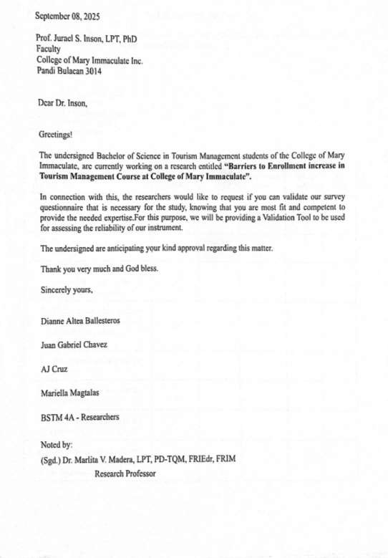
Appendix A

Letter of Request for Validation

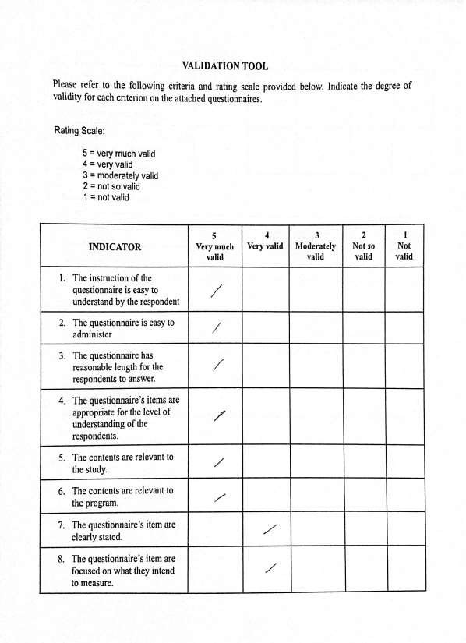

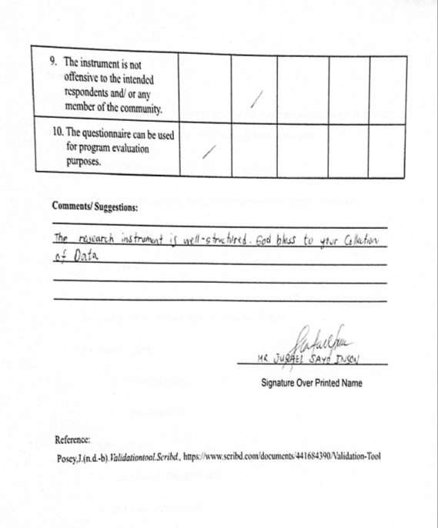

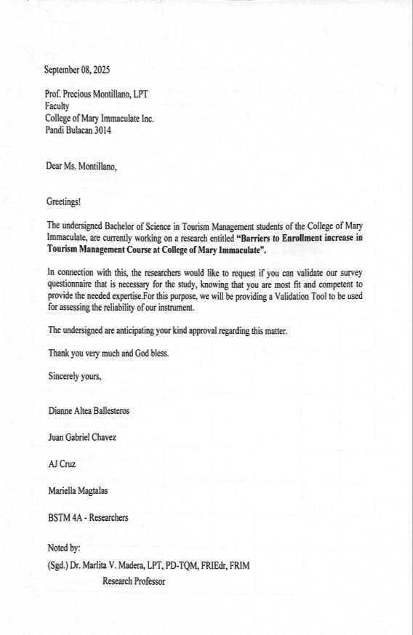

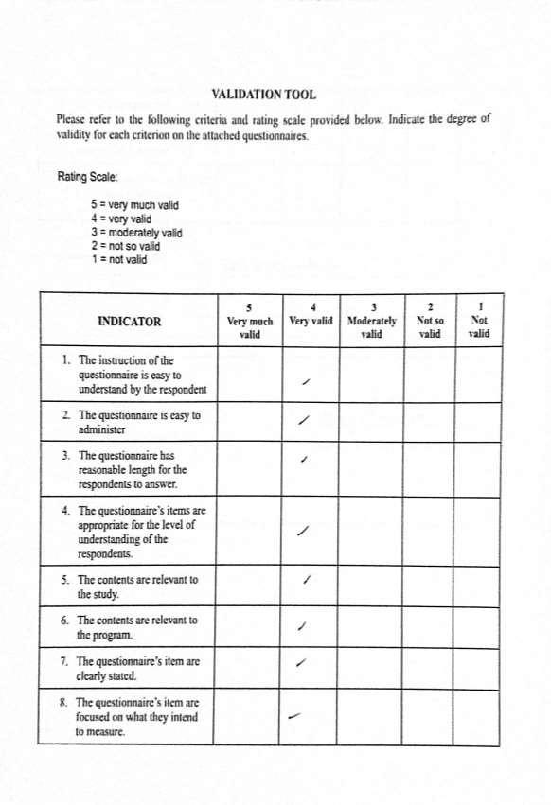

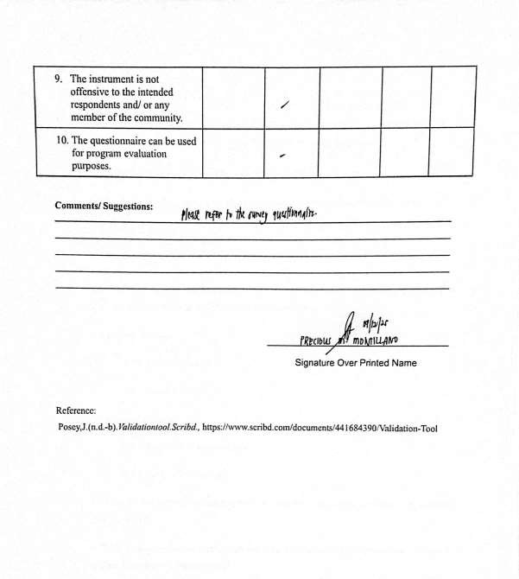

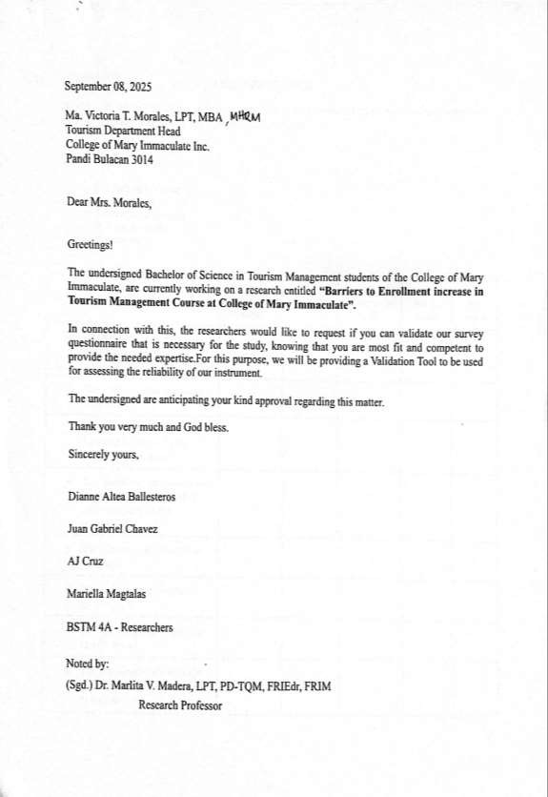

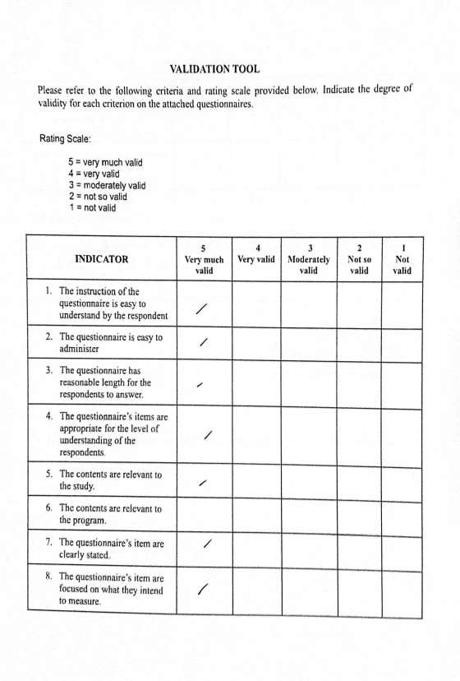

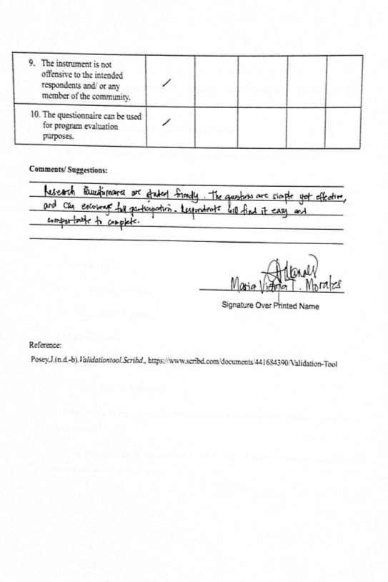

Appendix B

Letter of Request to Conduct the study

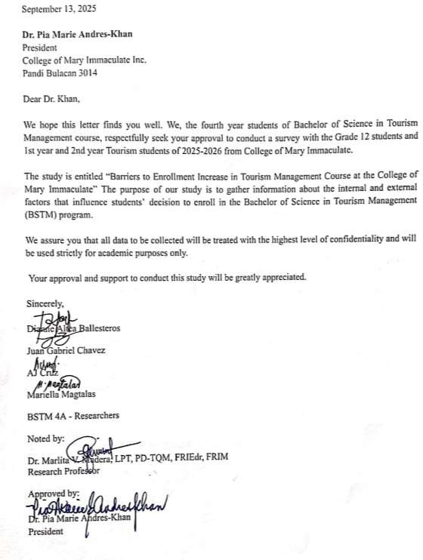

Appendix C

Validated Survey and Interview Questionnaire

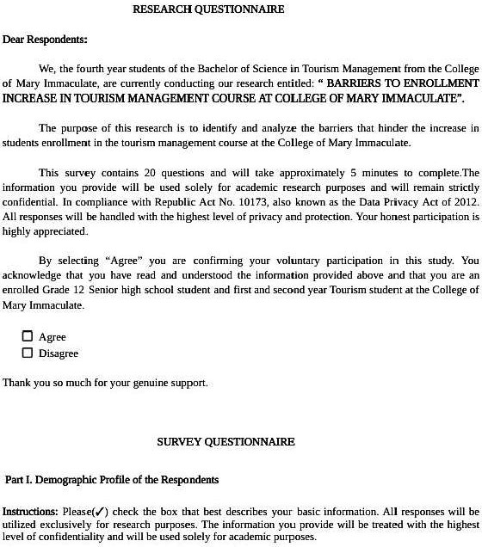

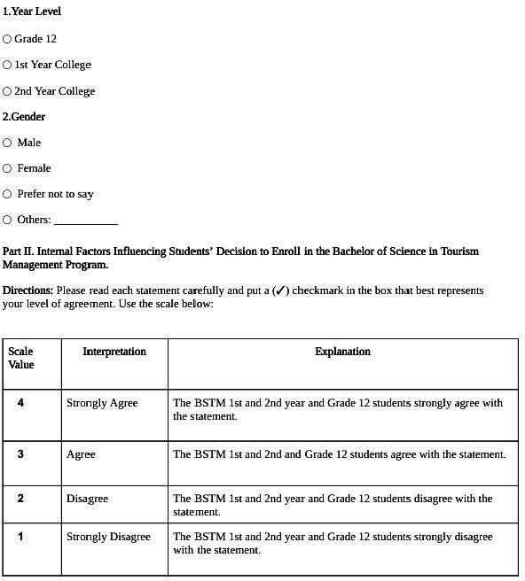

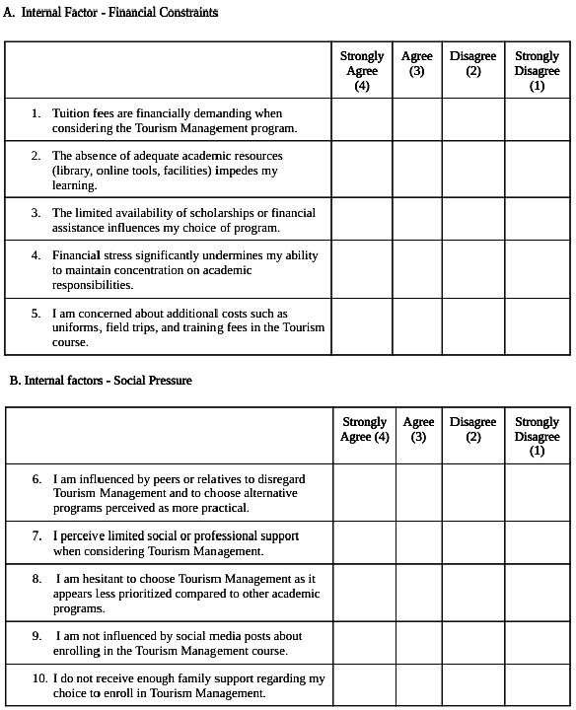

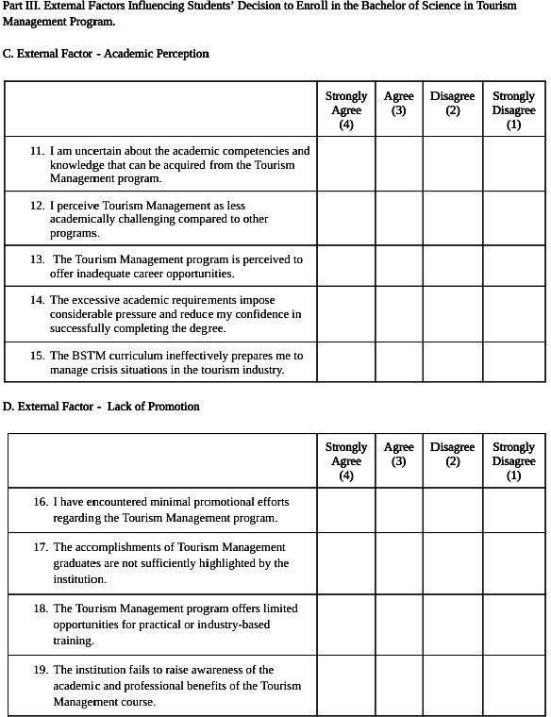
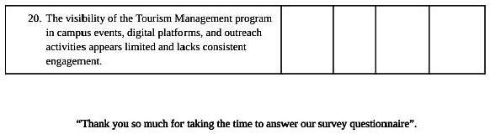

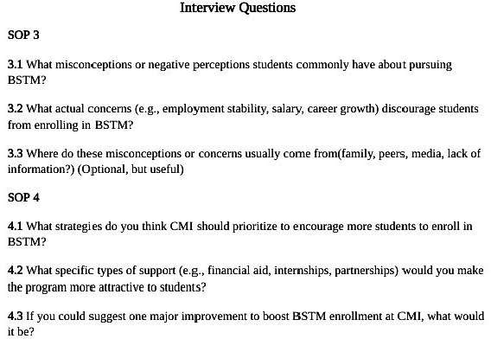

Appendix D Documentation of Collecting Data
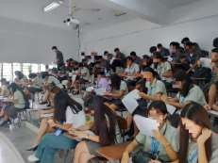
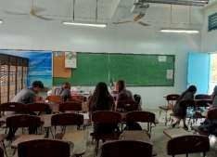

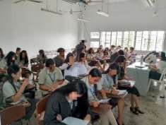
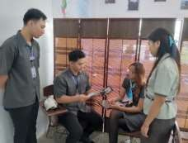

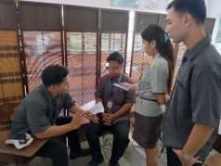


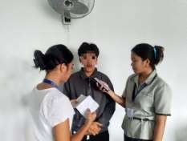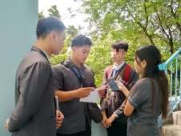




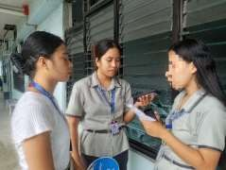

Appendix E Curriculum Vitae
